Information Security
Lecture: 01
What is Information Security?
Information Security (InfoSec) is all about protecting information from being misused, changed without permission, or made unavailable when needed. It involves steps and strategies to keep data safe from unauthorized access, ensuring that only the right people can use or modify it.
Key Points of Information Security:
- Preventive Steps: Actions taken to stop others from stealing, changing, or destroying information.
- Data Protection: Keeping knowledge, facts, and data safe from unauthorized use or changes.
- Design Strategies: Creating strong plans and systems that protect data when it’s stored, used, or shared.
- Critical Element Protection: Safeguarding important information and the systems that handle it from any threats.
Goal: The goal is to ensure Confidentiality (only authorized people can access), Integrity (data remains accurate and unchanged), and Availability (information is accessible when needed)
Information Security (Continue):
Information Security (IS) is about protecting everything an organization uses to handle information.
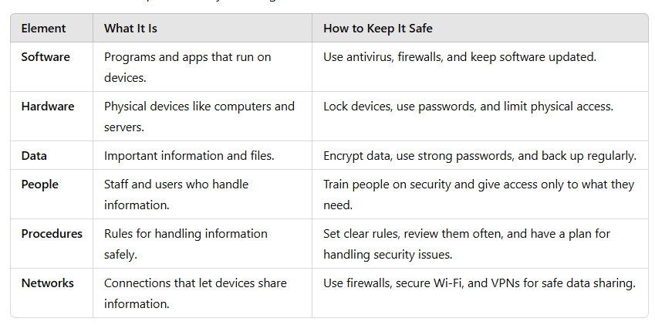
Pillars of Information Security:
- Confidentiality (only authorized people can access)
- Integrity (data remains accurate and unchanged)
- Availability (information is accessible when needed)
Importance of Information:
- IT is everywhere:
Information Technology (IT) is used in almost every part of society and is essential for running businesses and organizations.
- Example: Using smartphones, online shopping, or working on computers
- If not used properly: Without IT, daily tasks would be slower and harder. For example, no access to online classes or digital payments.
- Helps businesses and governments:
- Importance: IT makes tasks faster and easier for companies and governments.
- Example: Online banking, booking tickets, or paying taxes online.
- If not used properly: Businesses and governments would struggle to serve people efficiently. For example, standing in long queues for simple services.
- Personal information is important:
- Importance: We need personal details (like name, age, or phone number) for daily activities.
- Example: Using an ID to open a bank account or giving details at a hospital.
- If not protected: Personal details can be stolen and misused. For example, someone could use your bank details to steal money or use your ID for fraud.
- Information has value:
- Importance: Information helps in making good decisions.
- Example: Weather updates help you decide if you need an umbrella, or businesses use data to plan products.
- If not valued: Without good information, bad decisions can happen. For example, not knowing it will rain and getting wet, or a company losing money due to wrong data.
Protection of Information:
It means keeping information and the systems that use, store, or share it safe from misuse, theft, or damage.
Necessary Tools for Protection:
- Policy: Set rules and guidelines to handle and protect information.
- Awareness: Make people aware of security risks and how to avoid them.
- Training: Teach staff how to follow security rules and handle data safely.
- Education: Provide deeper knowledge about information security practices.
- Technology: Use tools like firewalls, antivirus, and encryption to protect data.
Securing Component in an IS:
Computers (Software and Hardware):
They are key parts of an Information System (IS) and play a major role in handling and protecting information.
Computers in Attacks:
- Subject of an Attack:
- The computer is used to carry out the attack.
- Example: A hacker uses a computer to send viruses or launch cyber-attacks.
- Object of an Attack:
  - The computer itself is the target of the attack.
  - Example: A hacker tries to break into your computer to steal data or install malware.

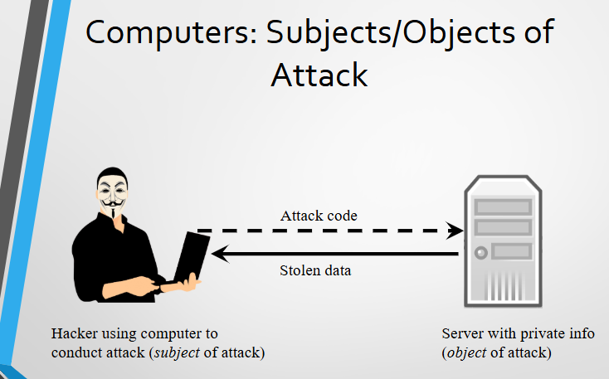
Important Terminologies:
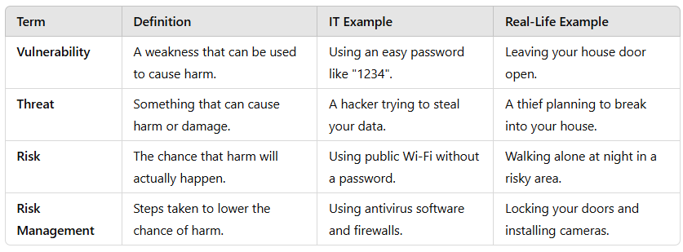
Security Mechanism:
- Identification:
  - Knowing who is trying to access something.
  - Example: Typing your username to log in
- Authentication:
  - Making sure you are really you.
  - Example: Using a password, fingerprint, or face scan to log in.
- Authorization:
  - Checking if you’re allowed to do something.
  - Example: The system checks if you can open a file or play a game.
- Physical Protection:
  - Using real-world tools to keep things safe.
  - Example: Locks on doors, cameras, or putting a laptop in a locked cupboard.
Threat Vs Danger:
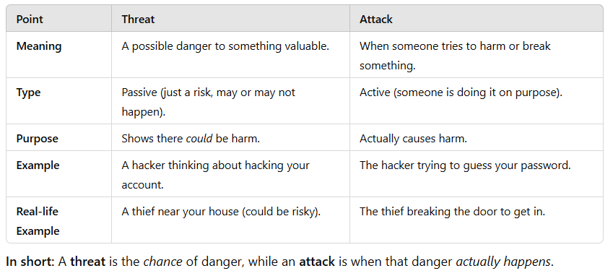
Types of Attacks:
- Backdoor
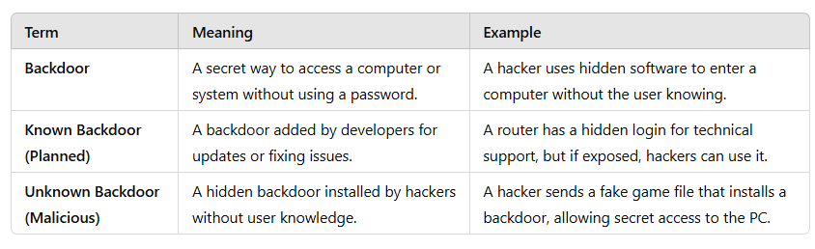
- Brute Force
A method where a hacker tries every possible password until they find the correct one.
- Example: A hacker uses software to try thousands of password combinations on a login page until it finds the right one, like trying “1234,” “abcd” and so on.
- Denial-of-service (DoS):
Attacker sends large number of connection or information requests to a target
- Target system cannot handle successfully along with other, legitimate service requests
- May result in system crash or inability to perform ordinary functions
- Distributed DOS
A type of cyberattack where many computers send a huge number of requests to a target system or website at the same time. This overloads the system, making it slow or causing it to crash so that real users can't access it.
- Spoofing
Spoofing is a trick where a hacker pretends to be someone trusted by using a fake identity, like a trusted IP address, to gain unauthorized access to a system or network.
- Main in Middle
A Man-in-the-Middle attack happens when a hacker secretly sits between two people or systems communicating. The hacker can watch, change, or steal the information being shared without either side knowing.
- Mail Bombing
Mail Bombing is a type of Denial-of-Service (DoS) attack where a hacker sends a huge number of emails to a target’s inbox, causing it to overflow, slow down, or crash.
- Sniffers
A Sniffer is a tool (software or hardware) that watches and captures data moving over a network. It can be used for good reasons, or for bad reasons, like stealing sensitive information.
- Social Engineering
Social Engineering is a trick where a hacker uses social skills to fool people into giving away sensitive information like passwords or bank details.
- Example: A hacker calls someone pretending to be from their bank and says, "There’s a problem with your account. Can you confirm your password?" If the person believes them and shares it, the hacker gains access.
Spam
Spam is unwanted emails sent to many people, mostly for ads. Sometimes, it can be dangerous and contain viruses or scams.
- Example: You get an email saying, “You won a prize! Click here!” It might be fake and try to trick you.
Buffer Overflow:
When a program gets more data than it can handle, causing it to crash or letting hackers run harmful code.
Timing Attack:
A hacker checks how long a system takes to respond and uses that info to guess secure data or steal cookies.
- Example: A hacker tracks response times to guess a password or access saved browser data.
Side-Channel Attack:
A hacker steals information by watching how a computer works, like recording keystrokes or screen activity.
- Example: Using a keylogger to secretly track what someone types, like passwords.

Lecture 02
CIA Triangle
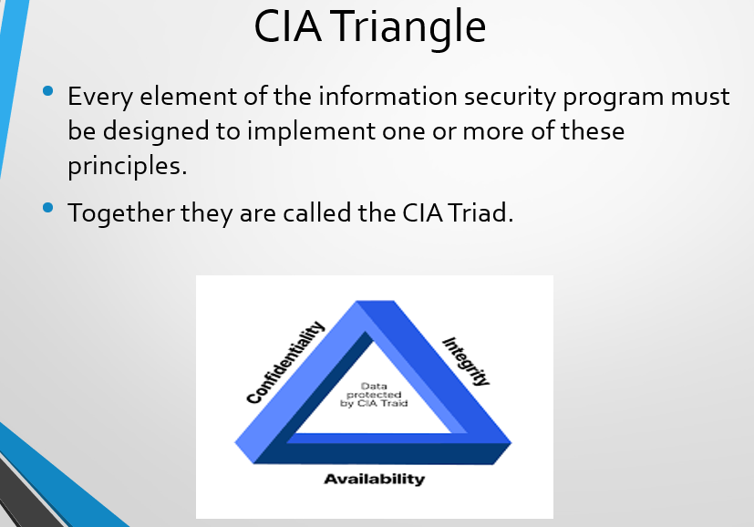
Threat vs Attack
- Security threats are potential (means something that could happen but has not happened yet) dangers that could harm your data or systems.
- Security attacks are intentional (means done on purpose and not by accident) actions taken to damage, steal, or disrupt your data.
These attacks can harm the confidentiality (privacy), integrity (accuracy), and availability (accessibility) of your information.

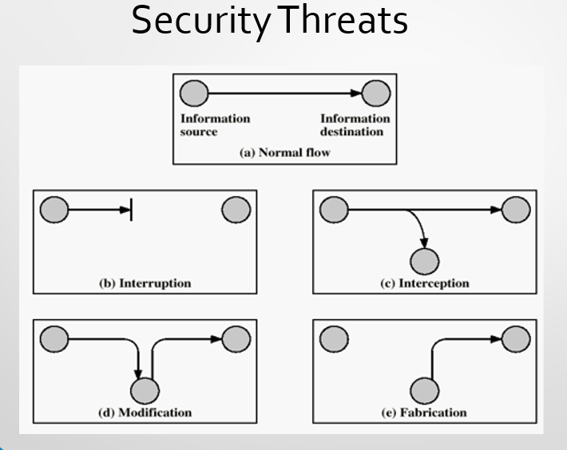
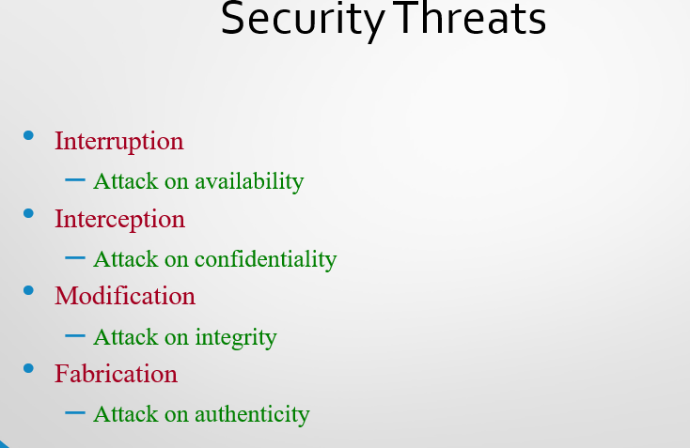
Acts of Human Error or Failure
- Inexperience → A new employee accidentally deletes important files.
- Improper Training (means employees don’t have the right knowledge or skills to follow security protocols) →Falling for phishing emails – An employee receives a fake email from a "bank" and enters company login details, allowing hackers to access company data.
- Incorrect Assumptions → Someone sends sensitive data to the wrong person, assuming it's safe.
Acts of Human Error or Failure
Employee mistakes can easily lead to:
- Revelation of classified data (Secret Data)
- Entry of erroneous data
- Accidental data deletion or modification
- Data storage in unprotected areas
- Failure to protect information
Many of these threats can be prevented with controls.
Deliberate Acts of theft:
Deliberate theft means illegally taking someone else’s property, whether physical, electronic, or intellectual.
- Physical theft is easy to prevent with security measures.
- Electronic theft is harder to detect because there may be no clear signs of the crime.
Q: Why Electronic Theft Is Harder?
- No Physical Evidence – Unlike physical theft, nothing is visible.
- Easily Hidden – Data can be copied without removing the original file.
- Hacking & Unauthorized Access – Thieves can access data remotely without being seen.
- Encryption & Anonymity – Cybercriminals can hide their identity and cover their tracks.
- Instant Transfer – Stolen data can be quickly sent anywhere in the world.
Deliberate Software Attacks
Deliberate Software Attacks (Malware): These are harmful programs that damage or disrupt systems.
Types include:
- Viruses: Spread with human action.
- Worms: Spread on their own through networks.
- Trojan Horses: Pretend to be safe but are harmful. (Example: A game or app that secretly steals your data)
- Logic Bombs: Hidden code that activates when triggered. (Example: A program that deletes files on a certain date)
- Backdoors: Secret ways to bypass security.
- DoS Attacks: Overload systems to make them crash.
Forces of Nature:
- Natural disasters (earthquakes, floods, storms) can destroy data and disrupt lives.
- They can damage computers, servers, and networks.
- Companies must have backup plans to reduce damage and recover quickly.
Classification of Attacks
Passive Attacks – Just watching and listening, without changing anything.
- Eavesdropping: Secretly reading messages.
- Traffic Monitoring: Observing data flow to gather information.
Active Attacks – Changing or interfering with data.
- Impersonation: Pretending to be someone else.
- Replaying Messages: Resending old messages to trick systems.
- Altering Messages: Changing data while it's being sent.
- Denial of Service (DoS): Blocking access to services by overwhelming them
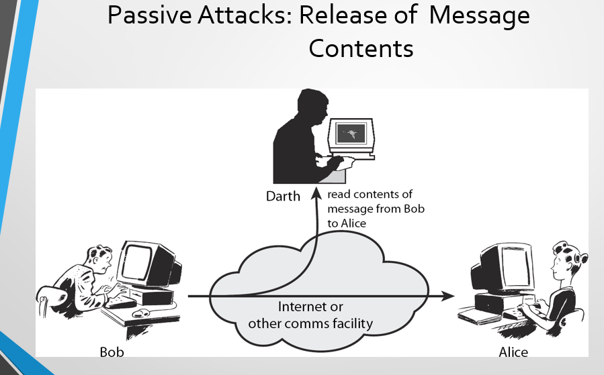
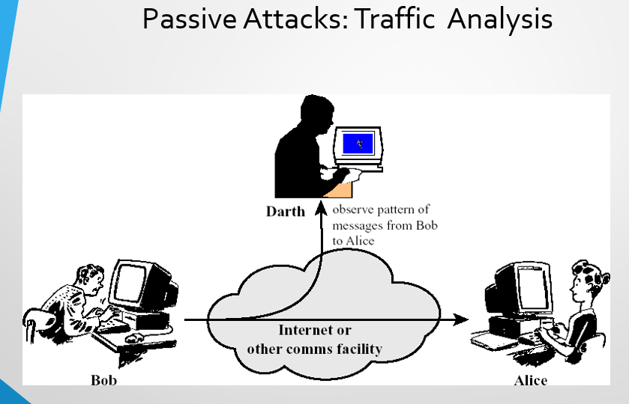

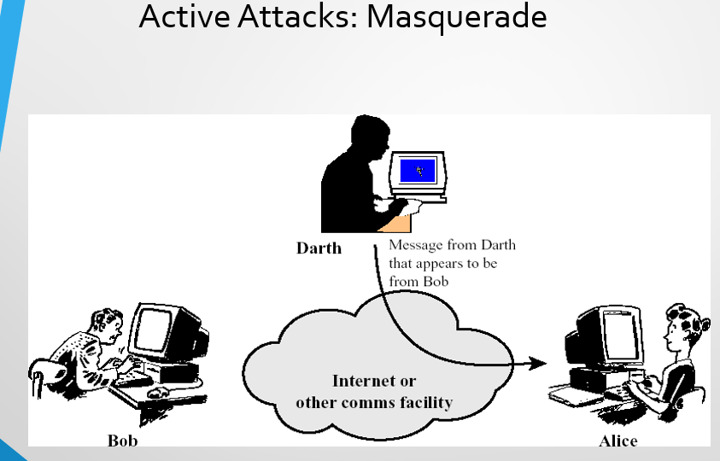
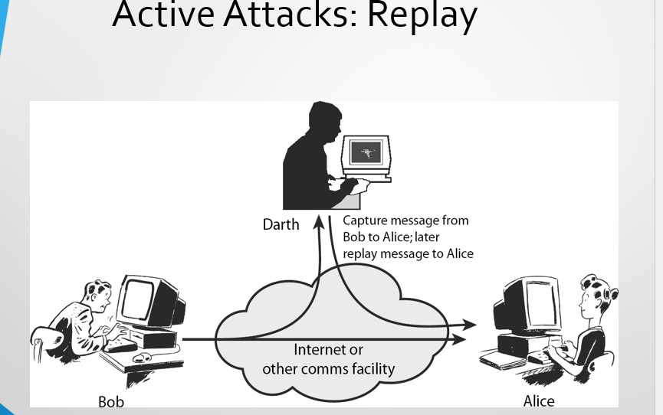
Replay:- Replay should be identical but with Delay(Spec type of Sniff)
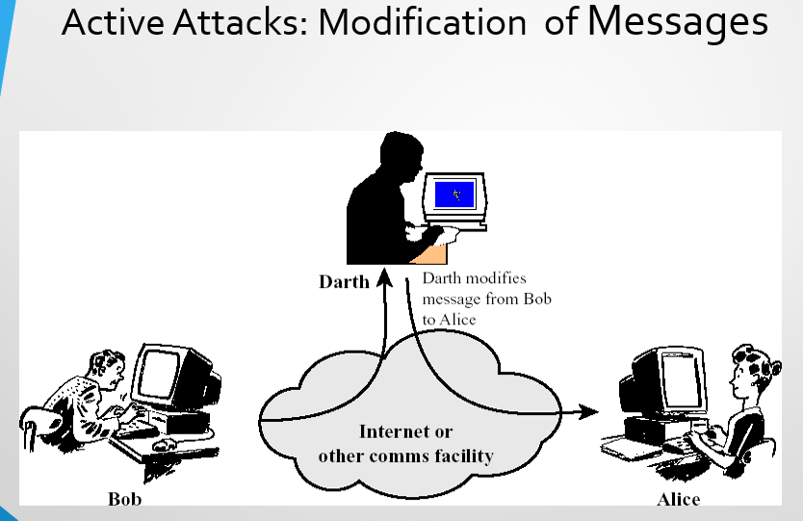
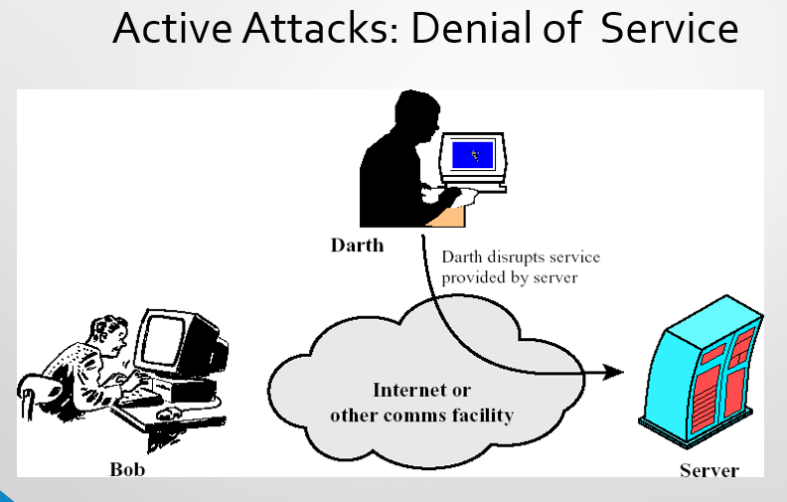
Lecture 3
Advance Persistent Threat
An APT is a long-term cyber attack where hackers secretly break into a network and stay there for a long time to steal important data. These attacks are carefully planned and usually target big companies or government systems. These are the not hit and run attacks.
Example:
"SolarWinds Attack" (2020)—where hackers inserted malware into a software update, allowing them to spy on U.S. government agencies and major companies for months without being noticed.
Consequences of an APT Attack:
An APT attack can cause serious damage, including:
- Theft of important company secrets (like patents or business strategies).
- Leak of private data (such as employee or customer information).
- Destruction of key systems (like deleting important databases).
- Complete control over a company’s website or network, allowing hackers to do anything they want.
Imortant Terms:
Minning:-"mine" means to secretly collect and extract valuable data over time, just like mining gold from a mountain. Hackers "mine" sensitive information by staying inside a network and gathering data slowly without being detected
Patent:- A patent is a legal right that gives an inventor ownership of their idea or invention. It means no one else can copy, make, or sell the invention without permission for a certain period (usually 20 years).
How APT is differ from another Threat?
- More advanced and complicated than normal attacks.
- Not hit and run—hackers stay inside the system for a long time to steal as much data as possible.
- Planned and targeted—they focus on specific victims instead of randomly attacking many people.
Cryptography
The term “cryptography,” derived from “crypt” meaning “hidden” and “graphy” meaning “writing,”. It is the study of encrypting and decrypting data to prevent unauthorized access to the data. It is the process of making and using codes to secure the transmission of information.
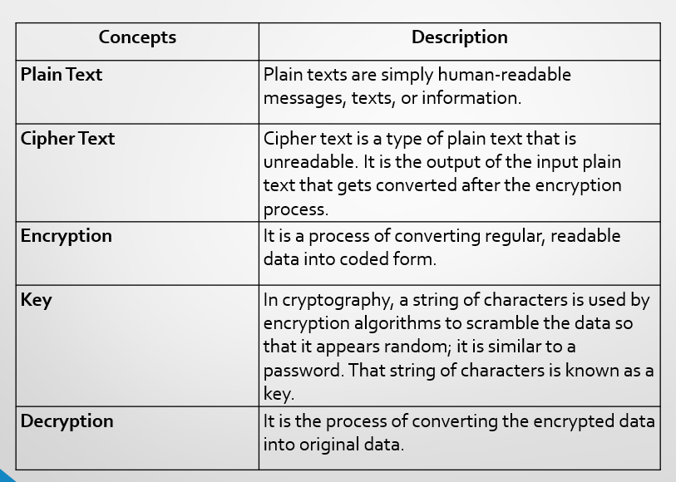
Important Terms:
- Cryptanalysis: The study of breaking secret codes to read messages without knowing the key or encryption method. (Like a hacker trying to crack a password.)
- Cryptology: The overall study of secret communication, including both creating (cryptography) and breaking (cryptanalysis) codes.
- Steganography: Hiding a message inside something else, like an image or text, so no one knows a secret message even exists.
Cryptography makes messages unreadable to outsiders (e.g., encryption).
Steganography hides the message so people don’t even know it’s there.
Cipher (Cryptosystem):
A cipher (or cryptosystem) is a method of encrypting and decrypting messages. It includes:
- The algorithm (rules for encryption). Example Caser Cipher.
- The key(s) (secret codes used to lock/unlock messages). Example Ceaser Cipher key = 3
- The steps to turn normal text into secret code and back.
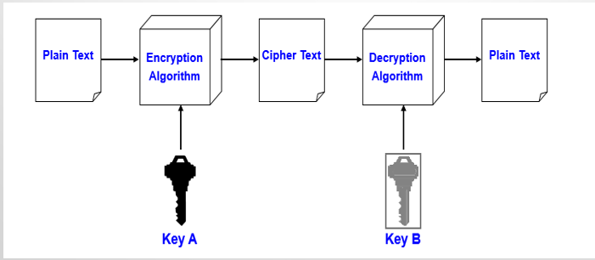
Cipher Methods
There are two methods of encrypting plaintext:
- Bit stream method
- Block cipher method
Bit-stream Method
- In the bit stream method, each bit in the plaintext is transformed into a cipher bit one bit at a time.
- Bit stream methods commonly use algorithm functions like the exclusive OR operation (XOR).
- A keystream (sequence of random bits) is generated and XORed with the plaintext bits.
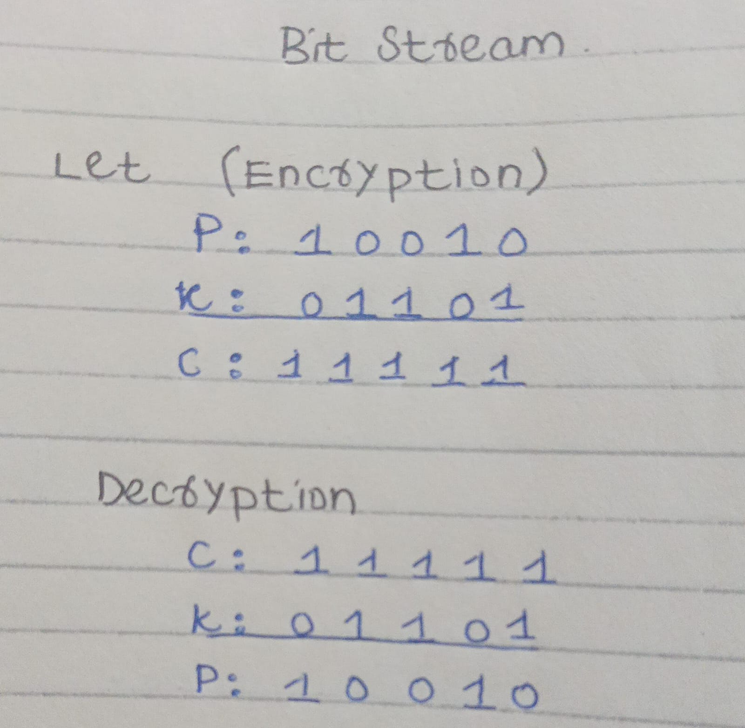

Block Cipher Method
- In the block cipher method, the message is divided into blocks.
- For example, sets of 8-, 16-, 32-, or 64-bit blocks, and then each block of plaintext bits is transformed into an encrypted block of cipher bits using an algorithm and a key.
- If the message is not the multiple, then padding is done.
- Block methods can use substitution, transposition, XOR, or some combination of these operations.
How Does Cryptography Works?
Cryptography transforms plaintext or data into unreadable ciphertext, which can only be converted back into a readable form by authorized parties using decryption keys.
It involves three main steps:
- Step 1: The first step involves selecting an encryption algorithm like AES or RSA.
- Step 2: Using these algorithms, transform readable data into an unreadable format of bit sequences (cipher text).
- Step 3: In the last step, using decryption keys, convert the cipher text back into the original plain text format.
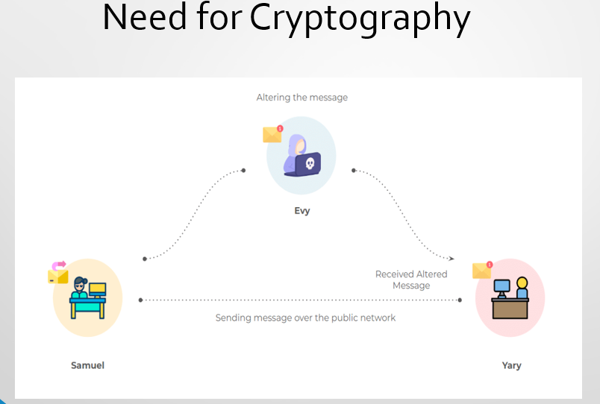
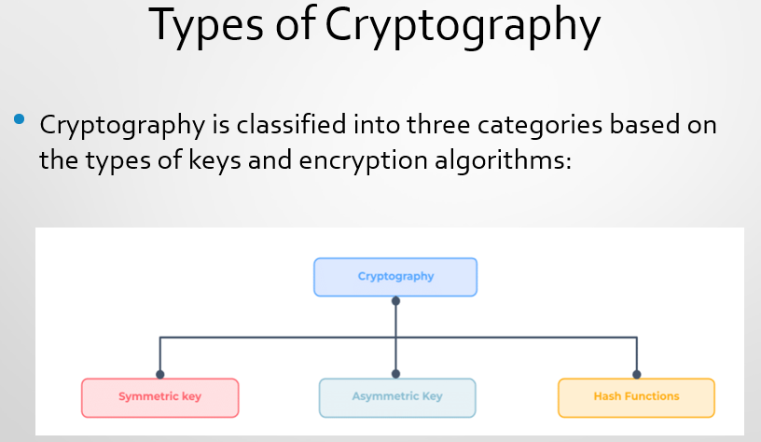

Symmetric Key Cryptography
- Also known as Secret Key Cryptography or private key encryption.
- The same key is used by both the sender and the recipient, ensuring secure communication.
- The shared key is used to encode the plaintext into ciphertext during transmission.
- This ciphertext can only be deciphered by the recipient who has the matching key.
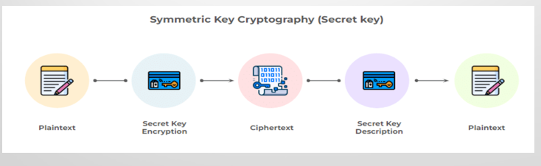
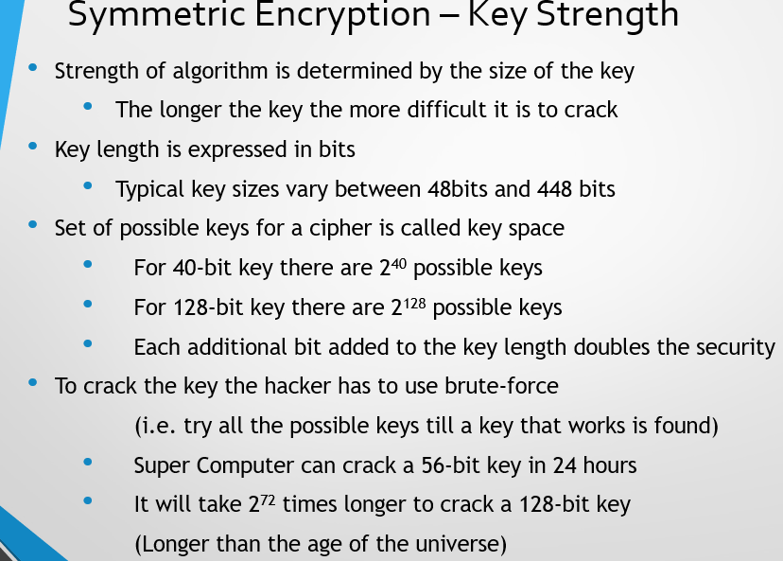
Asymmetric Cryptography
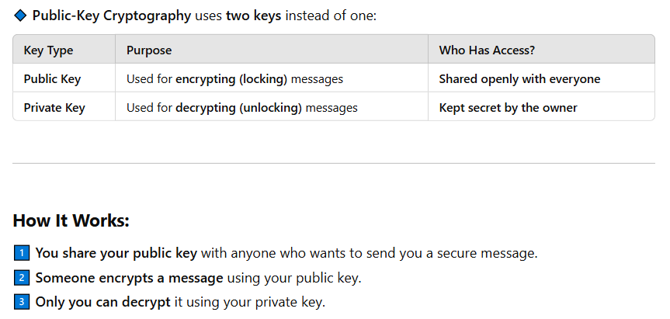
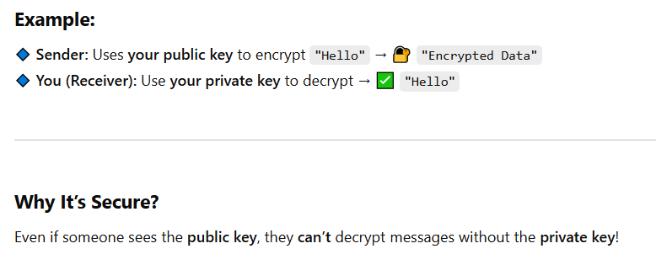
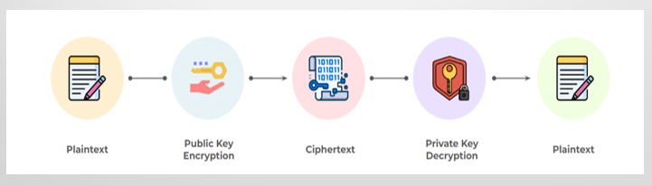
Note: Both keys are generated by receiver
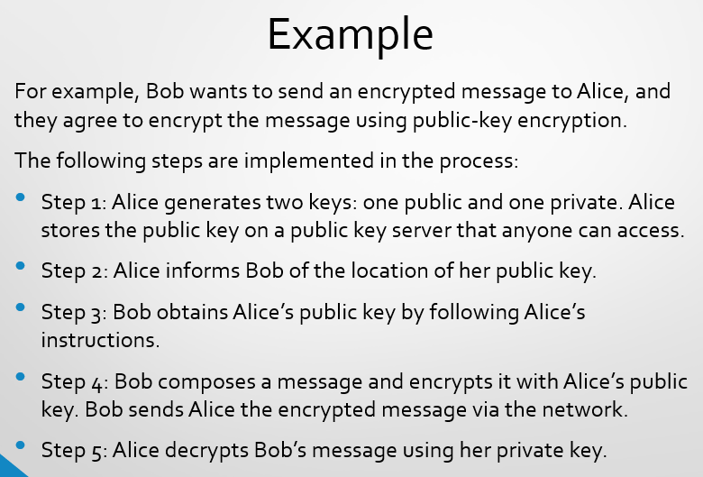
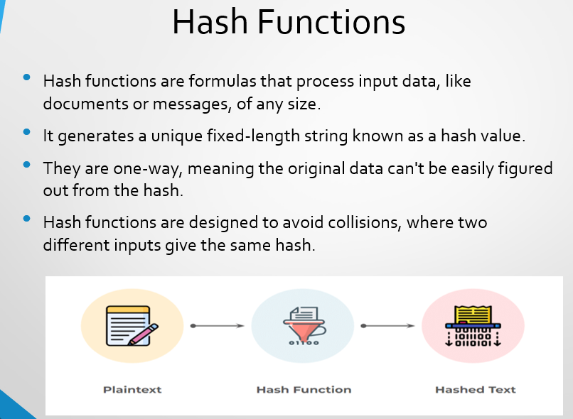
Lecture 04
Substitution Cipher\Symmetric
- To use substitution cipher, you substitute one value for another.
- For example: a letter in the alphabet with the letter three values to the right
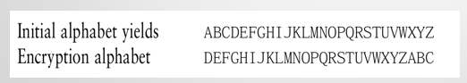
Types:
Caesar Cipher
- Each alphabet in the message is replaced by three places down.
Monoalphabetic substitution
- It only uses one alphabet.
Polyalphabetic substitutions
- More advanced substitution ciphers use two or more alphabets

Caeser Cipher
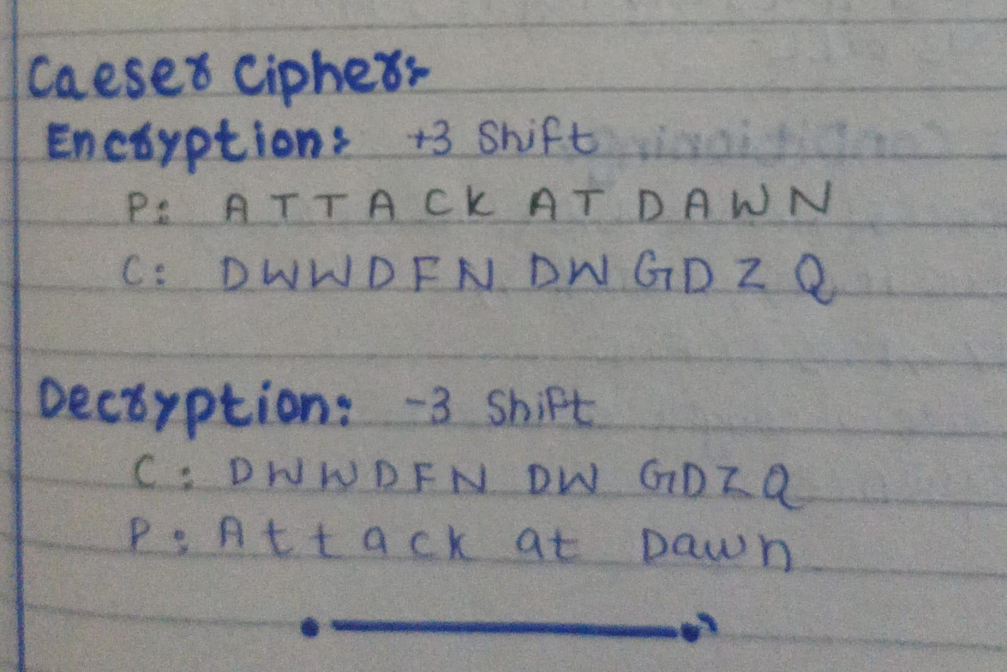
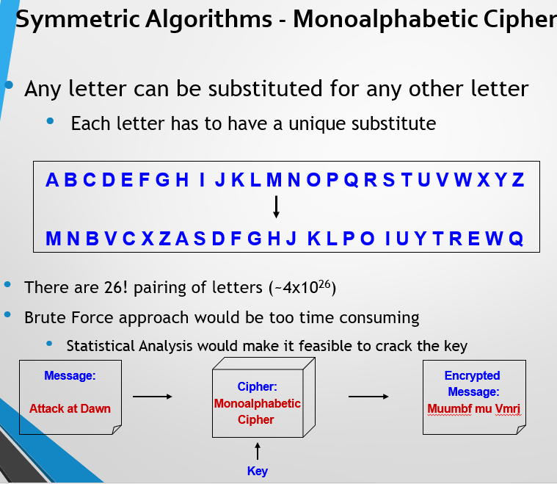
Statistical Analysis
1. Letter Frequency Analysis
- Some letters appear more frequently than others in English text.
- Example: E (~13%) and T (~9%) are the most common.
- If an encrypted text has one letter appearing the most, it is likely E or T.
2. Common Letter Combinations (Bigrams & Trigrams)
- Certain letter pairs (bigrams) and triplets (trigrams) appear often:
  - Bigrams: "TH", "IN", "ER"
  - Trigrams: "THE", "ING", "ION"
- If a certain symbol appears frequently together, it might represent these.
3. Context-Based Cracking
- If we have a general idea about the text (e.g., it’s about history), some words are more likely.
- This makes it even easier to guess substitutions.
Conclusion:
Even though brute force would take forever, statistical patterns allow attackers to crack monoalphabetic ciphers easily. That’s why they’re not secure for modern encryption.
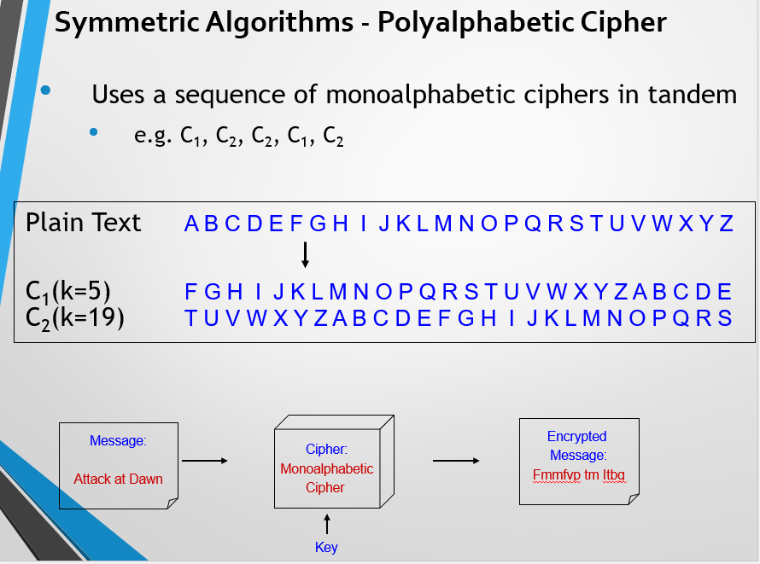
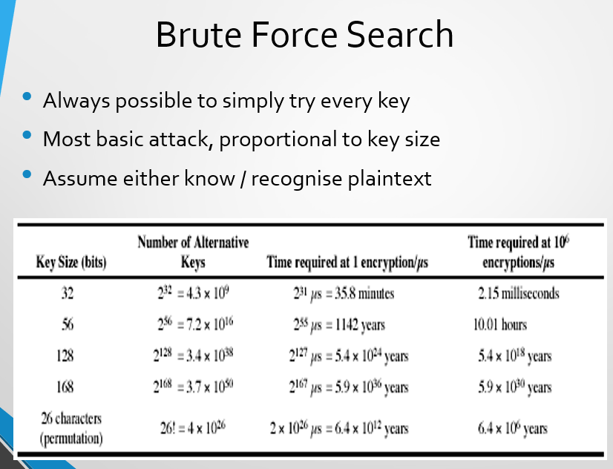
Monoalphabetic Security
- We have a total of 26! = 4 x 10²⁶ keys
- With so many keys, might think is secure
- But would be !!!WRONG!!!
- Problem is language characteristics
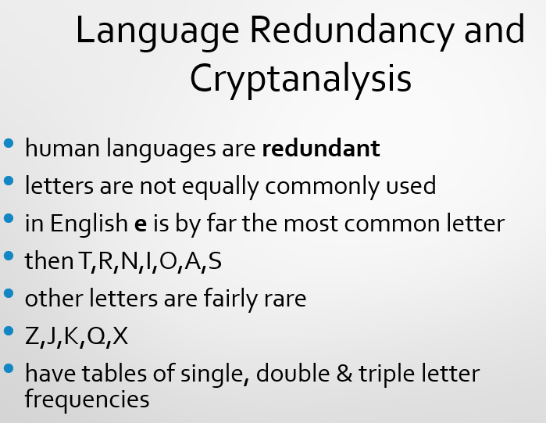
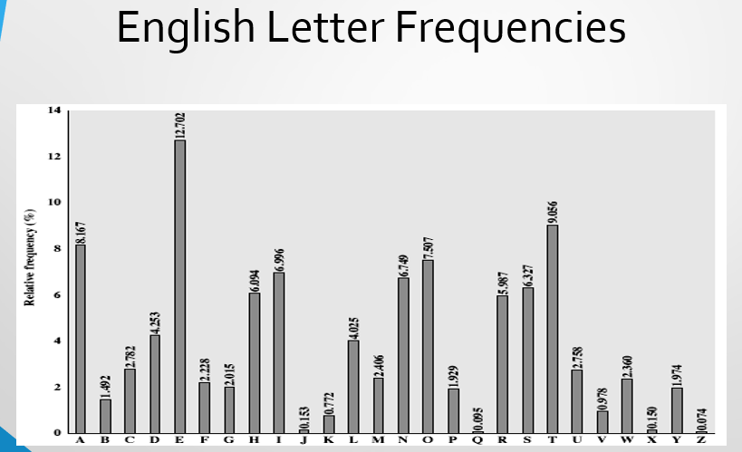
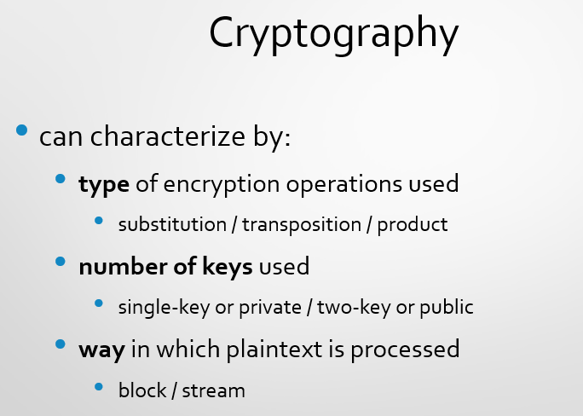

Lecture 05
Vigenère Cipher
The Vigenère cipher is a method of encrypting and decrypting text using a series of Caesar ciphers based on a keyword. It is a form of polyalphabetic substitution cipher, which makes it more resistant to frequency analysis compared to simple substitution ciphers. It is Made up of twenty-six distinct cipher alphabets.
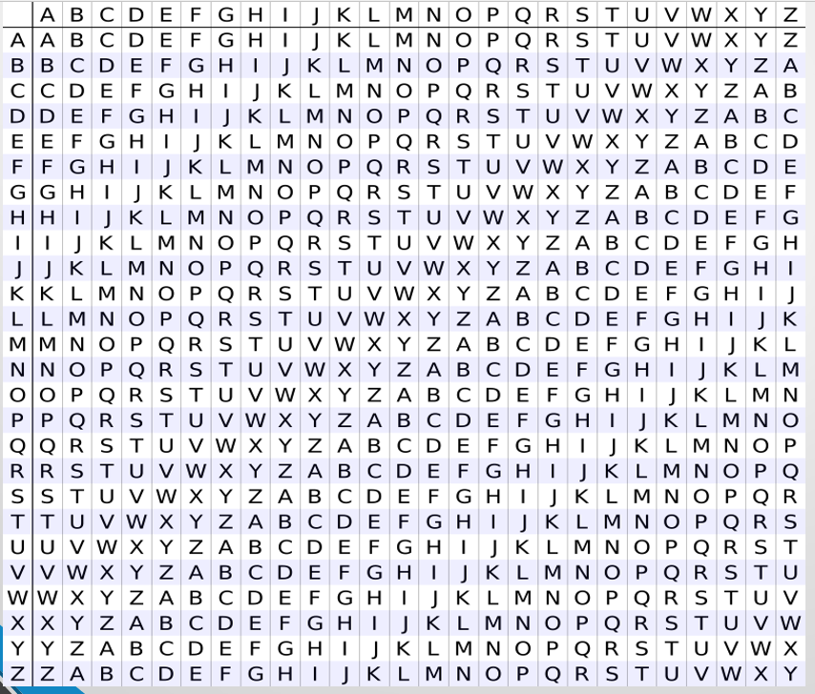

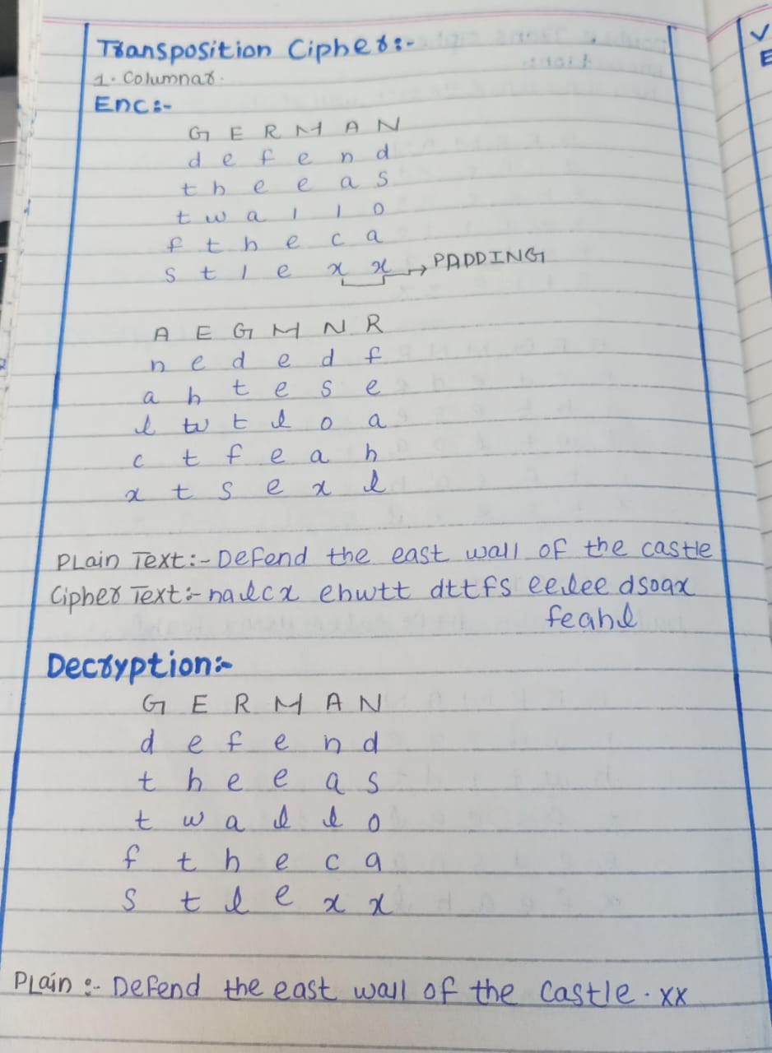

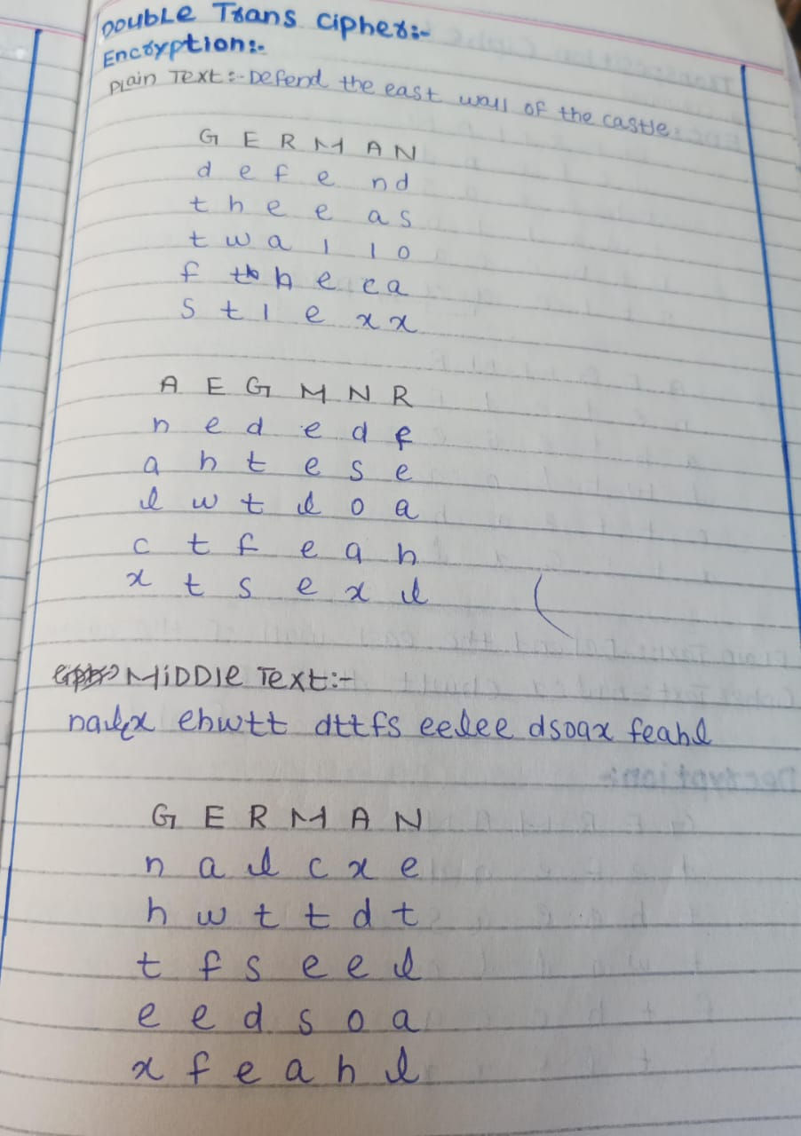

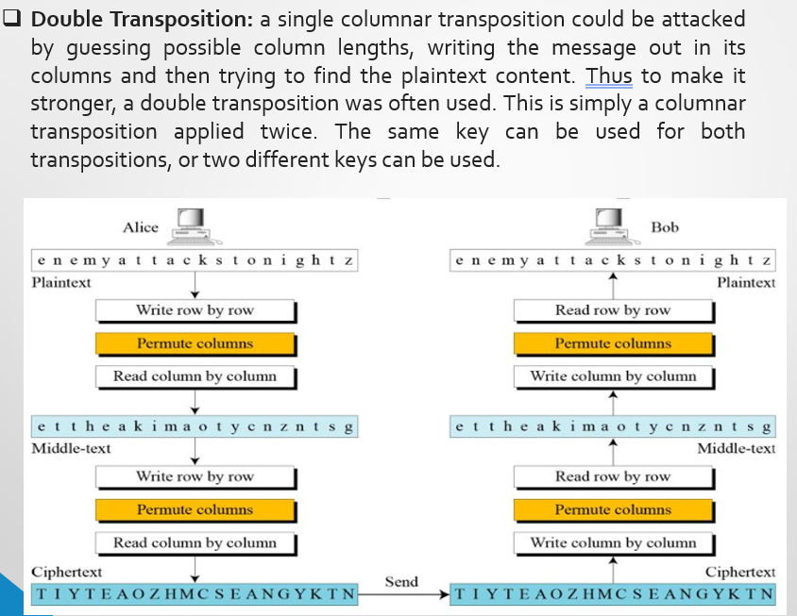
Lecture 06
KercKhoff Principle:
Kerckhoff, a Dutch-born cryptographer, stated that “that a cryptographic system should remain secure even if everything about how it works is known, except for the secret key”.
Claude Shannon simplified this as "The enemy knows the system", meaning we must assume that attackers will understand how encryption works, so the only thing keeping data safe is the key.

One time Pad
- Fix the vulnerability of the Vigenère cipher by using very long keys.
- Key is a random string that is at least as long as the plaintext.
- Encryption is similar to shift cipher.
- Invented by Vernam in the 1920s
Q: How Vigenère is weak?
The Vigenère cipher is weak because its repeating key creates patterns that allow frequency analysis to break it. If the key is short, attackers can guess it using Kaiseki examination or Brute force.
Difference between Vigenère & Onetime Pad
Vigenère Cipher (Weakness Example)
- Plaintext: HELLOHELLOHELLO
- Key: KEYKEYKEYKEYKEY (repeats)
- Ciphertext: RIJVSUYVJNRIJVS
- Since the key repeats, an attacker can find patterns and break the encryption.
One-Time Pad (Perfect Security Example)
- Plaintext: HELLOHELLOHELLO
- Key: XMCKLZPWQNRXWET (random, same length as plaintext)
- Ciphertext: (random, no pattern)
- Since the key is random and never reused, even if an attacker intercepts the ciphertext, they cannot decrypt it without the exact key.

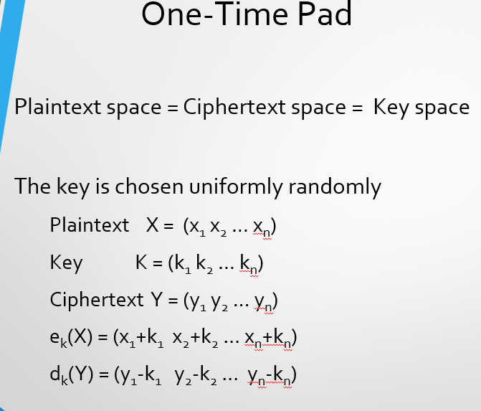
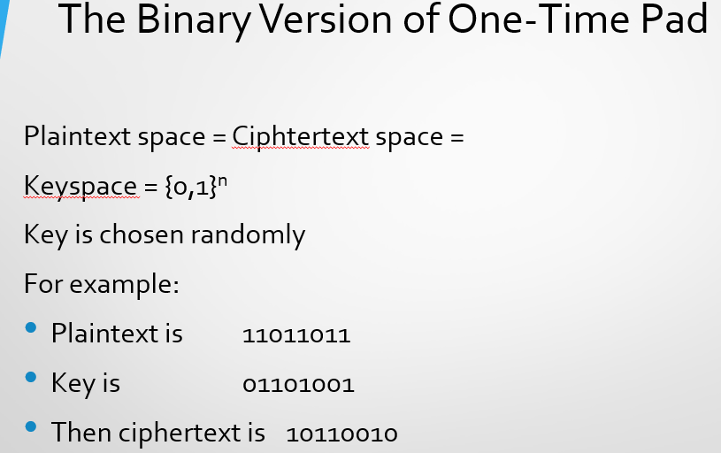
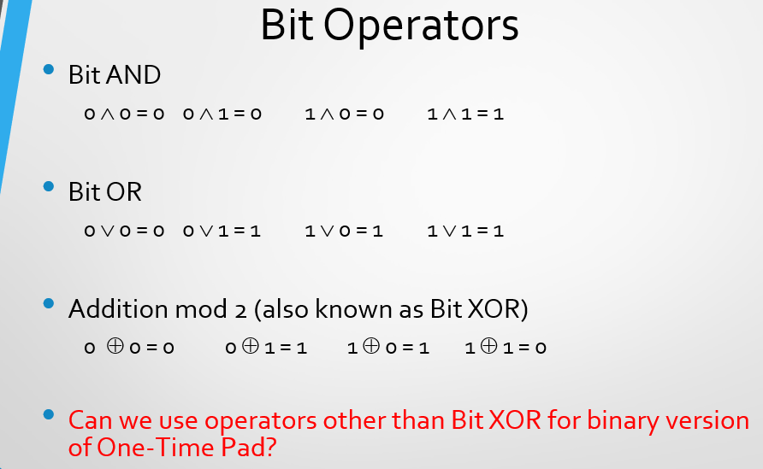
Ans: Yes, we can use other operators but they are not as much good as XOR. If we take AND OR operator and perform encryption there is a 70% of chances that a user might guess the correct key while in XOR these chances reduce to 50% so this make XOR good to use in encryption algorithm.
How Good One-Time-Pad Is?
One-Time Pad is secure because the key is completely random, making the ciphertext also appear random. An attacker cannot learn anything about the plaintext, not even a single bit of information. They can't even tell if the plaintext is "aaaa" or "bbbb" because every possible plaintext is equally likely.

Perfect Secrecy
Perfect secrecy is a cryptographic concept that refers to a situation where an attacker gains no information about the contents of a message, even after inspecting the ciphertext, with unlimited resources.
- “Ciphertext only” attack model.
- The attacker only has information about the ciphertext. The key and plaintext are secret.
- Perfect secrecy achieved when:
  - the attacker learns nothing from the ciphertext.
Stream Cipher
A stream cipher is a symmetric key cipher where plaintext digits are combined with a pseudorandom cipher digit stream (keystream).
In a stream cipher, each plaintext digit is encrypted one at a time with the corresponding digit of the keystream, to give a digit of the ciphertext stream.
Stream Cipher Continue…
- In a stream cipher structure, a key is input to a pseudorandom bit generator that produces a stream of 8-bit numbers that are apparently random.
- A pseudorandom stream is one that is unpredictable without knowledge of the input key and which has an apparently random character.
- The output of the generator called a keystream, is combined one byte at a time with the plaintext stream using the bitwise exclusive-OR (XOR) operation.
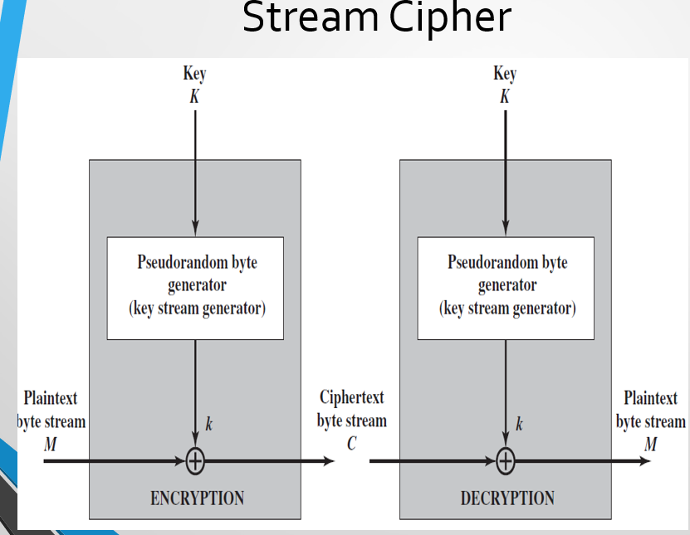
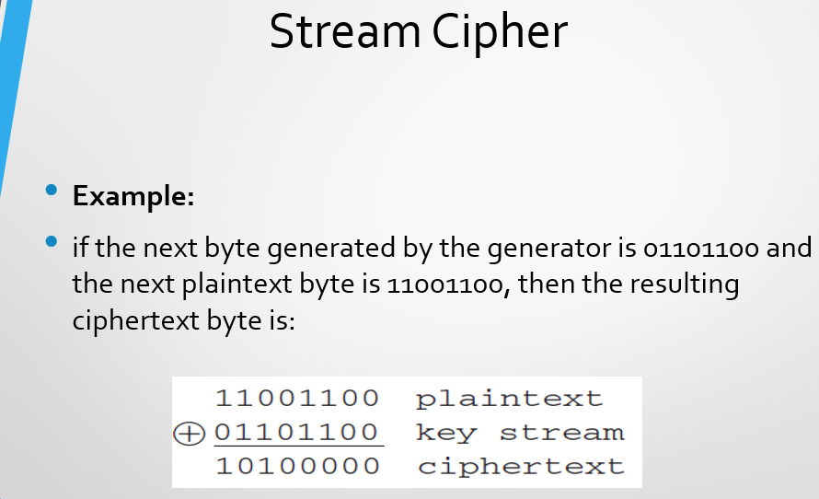
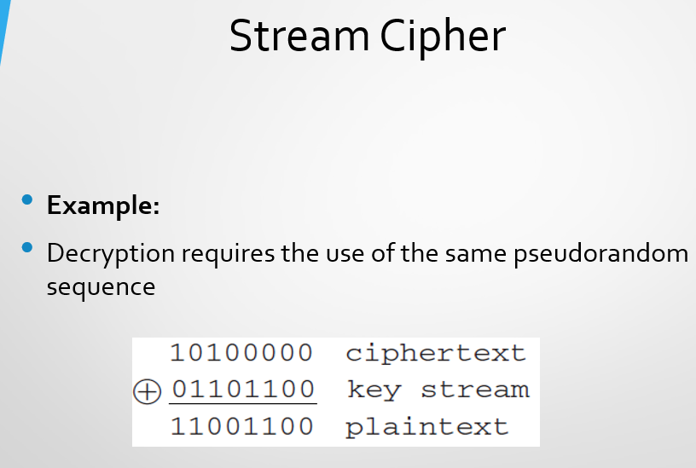
Stream Cipher Continue…
- The more random-appearing the keystream is, the more randomized the ciphertext is, making cryptanalysis more difficult.
- As the output of the pseudorandom number generator is conditioned on the value of the input key, to guard against brute-force attacks, the key needs to be sufficiently long.
- With the current technology, a key length of at least 128 bits is desirable.

Lecture 07
Random Number
A random number is a number that is selected from an infinite set or finite range, in which each number in the range is equally likely to be selected
Key Points
- True random numbers come from natural events, like rolling dice, where the outcome is completely unpredictable.
- They do not follow any mathematical pattern or formula.
- Used in highly secure encryption and scientific simulations.
- Random number generation is a method of producing a sequence of numbers that lack any obvious pattern.
Pseudo Random Number
When it comes to the computer program or computational machine which has to generate a random number, then at the back there always will be some mathematical process or a function or a particular algorithm procedure which will produce a random number. So, ultimately here random numbers are not actually random as it follows some sequence and hence it is known as "PSEUDO RANDOM NUMBER".
Key Points
- A Pseudorandom Number Generator (PRNG) is a method that creates a sequence of numbers that look random but are actually based on an initial starting value called a seed.
- Since PRNGs follow a set formula, their numbers are not truly random, but they are useful because they are fast and can be reproduced when needed.
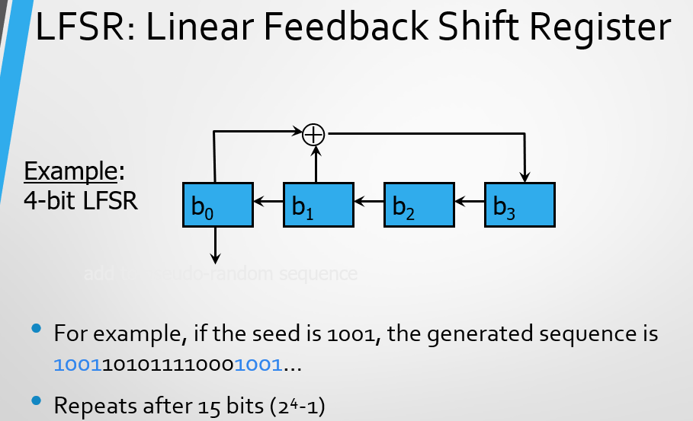

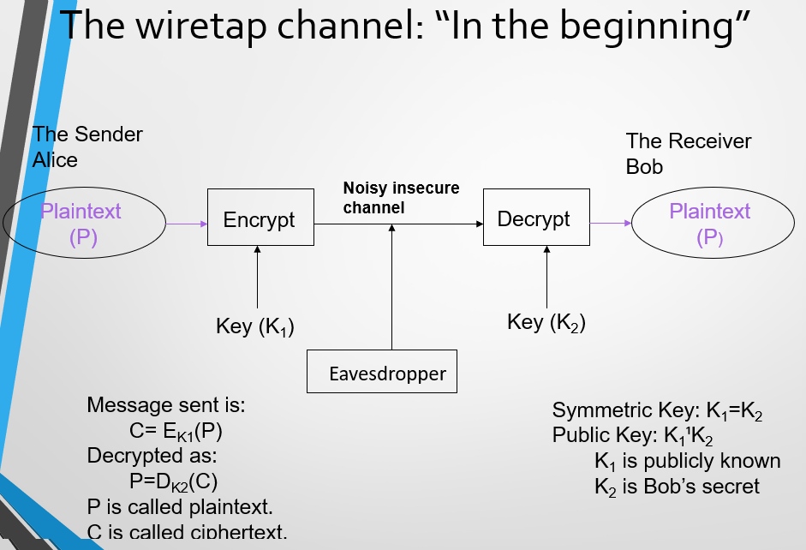

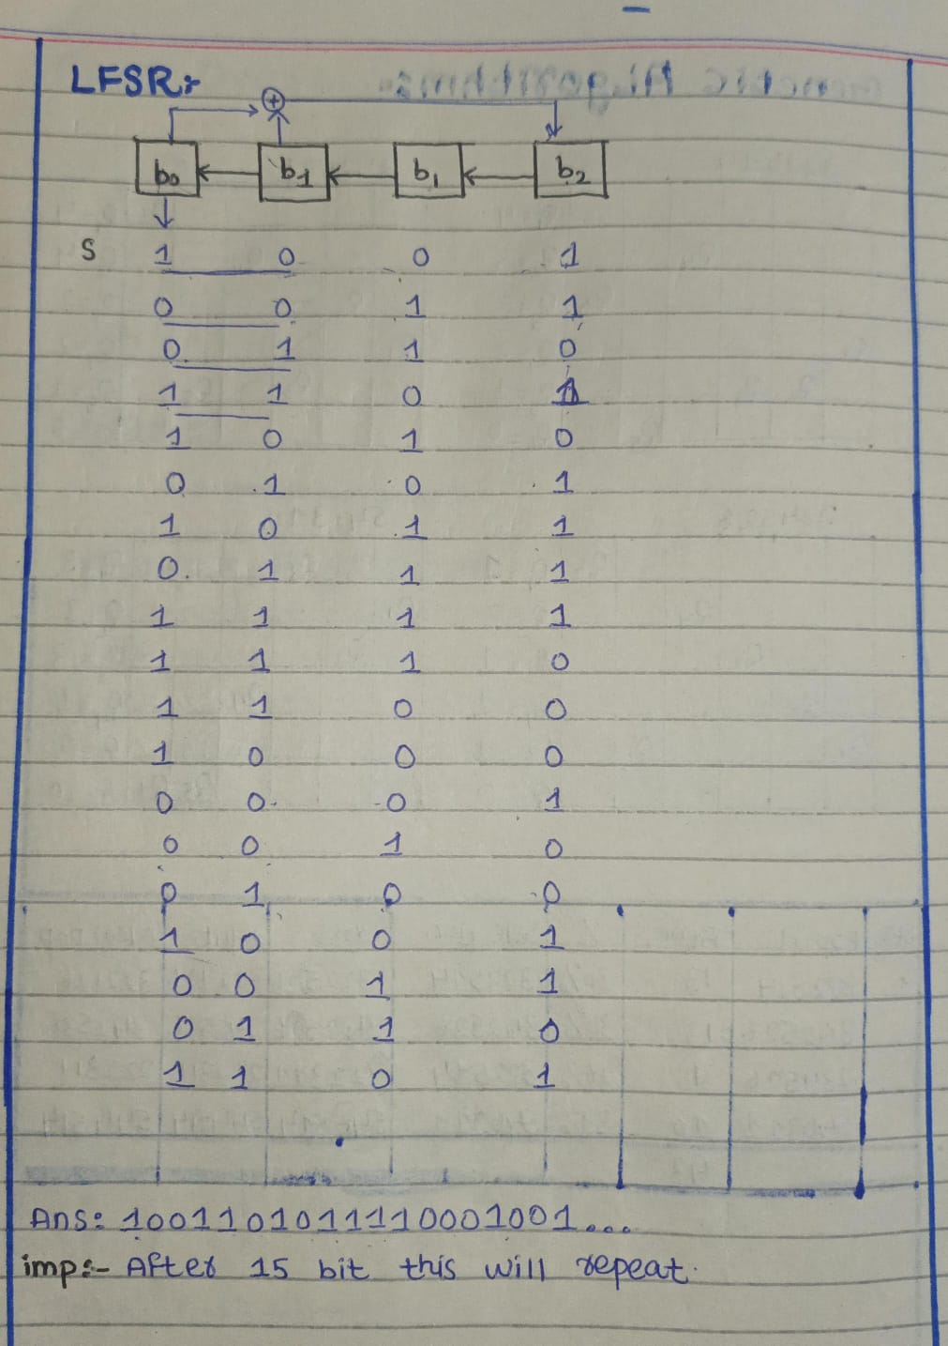
Cryptography & Adversaries
- Cryptography is used to protect information in the presence of adversaries.
- Important Questions to consider in cryptographic security:
  - What do you want to protect? (e.g., data, messages, passwords)
  - Against whom? (e.g., hackers, organizations, governments)
  - Under what circumstances? (e.g., online communication, data storage, financial transactions)
Adversary (Attacker) Characteristics:

An adversary is anyone trying to break security measures and is defined by:
- Talent: Their skills and expertise in cryptanalysis.
- Access to Information: How much data they can intercept or manipulate.
- Computational Resources: The power of their hardware and algorithms.
Takeaway:
Cryptography is not just about encrypting data but also about understanding potential threats and ensuring protection against them.

Computational Strength of Adversary
Perfect Security (Impossible to Break)
- This kind of security is so strong that even with unlimited time and computing power, no one can break it.
- It does not depend on how powerful computers are.
- Example: The One-Time Pad is a type of encryption that is 100% unbreakable if used correctly.
Realistic Security (Hard to Break in Practice)
- This type of security depends on how powerful computers are and how much time an attacker has.
- It is designed to be very difficult to break with today's technology.
- Example: Modern encryption methods like AES (Advanced Encryption Standard) take thousands of years to break with current computers.
Practical Attacks
- Brute Force Attack (Exhaustive Search) – Trying every possible key until the right one is found.
- Weak Key Usage – Poor key choices make it easier to guess or crack.
- Bad Key Management – If keys are stored carelessly or shared improperly, attackers can steal them.
- Stealing Keys – Directly obtaining encryption keys through hacking or social engineering.
- Encryption Errors – Mistakes in encryption methods can expose data.
- Spoofing (Impersonation) – Pretending to be someone else to access restricted information (like faking an ATM PIN).
- Information Leaks – Attackers analyze data patterns, timing, or even hardware signals to extract sensitive information.
Towards Computational Security
- Perfect security is hard to achieve.
- Instead, we focus on computational security, which is practical.
- We assume attackers have limited computing power.
- They only get a short time to break the encryption.
- Even if they succeed, the chance is extremely small, so we ignore it.
Defining Security
- Desire “semantic security”, i.e., having access to the ciphertext does not help adversary to compute any function of the plaintext.
- Difficult to use
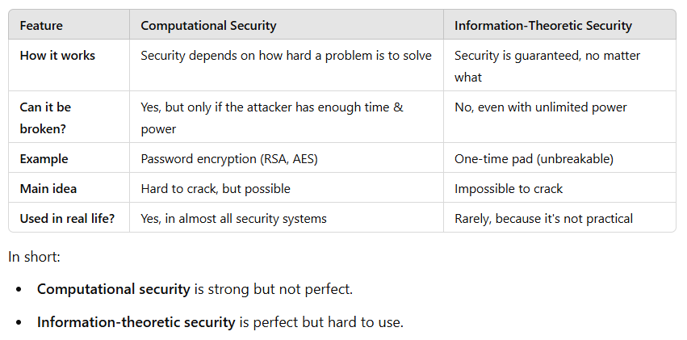
- Equivalent notion: Adversary cannot distinguish between the ciphertexts of two plaintexts
Lecture 08
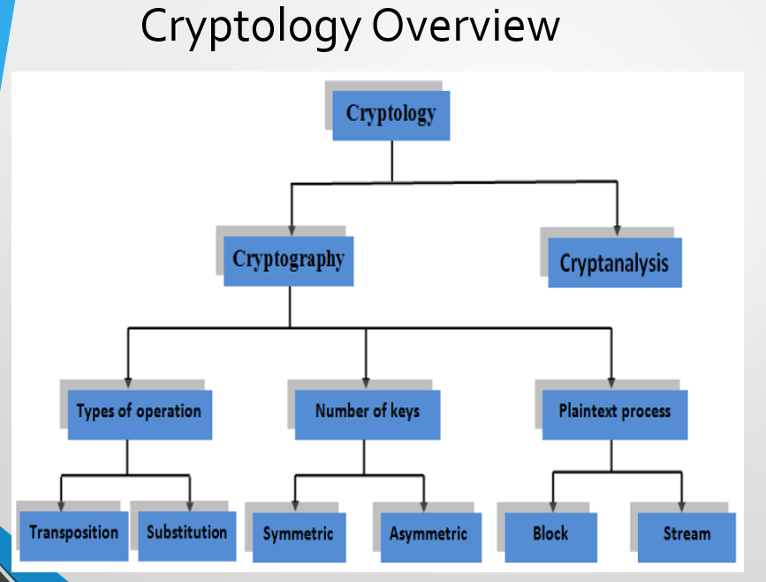
Frequency Analysis
Frequency analysis is the study of the frequency of letters or groups of letters in a ciphertext. This technique is commonly used to break substitution ciphers, such as mono-alphabetic substitution ciphers and Caesar shift ciphers.
How Frequency Analysis Works
Frequency analysis involves counting the occurrence of each letter or letter combination in a given text. By studying the frequencies, patterns can be recognized, helping to decode the message.
Application of Frequency Analysis in Cryptography
This method is often used as an aid in breaking substitution ciphers. Since certain letters appear more frequently in natural languages, the analysis of letter frequency can assist in identifying the original letters of the ciphertext.
Example of Frequency Patterns in English
In English, letters like E, T, A, and O are among the most common. In contrast, letters such as Z, Q, and X are less frequently used. Recognizing these patterns can help in deciphering a coded message.
Why block ciphers?
Using Different Keys in Different Locations
One way to defeat frequency analysis is by using different keys in different locations in the ciphertext. This means that even if a certain letter or pattern repeats, its encryption changes because the key used changes at different points in the message.
Examples: One time pad, stream ciphers
Another way to defeating Frequency Analysis
Frequency analysis works by identifying recurring letter patterns in ciphertext. To combat this, encryption methods such as block ciphers are used. Block ciphers encrypt data in larger units, rather than letter-by-letter encryption, which helps to make frequency analysis less effective.
Examples: block cipher

Block vs Stream Cipher
Block
Block ciphers process messages in blocks, each of which is then encrypted and decrypted
- Like a substitution on very big characters
- 64-bits or more
Stream
Stream ciphers process messages a bit or byte at a time when
encrypted and decrypted
Many current ciphers are block ciphers
- Better analyzed
- Broader range of applications
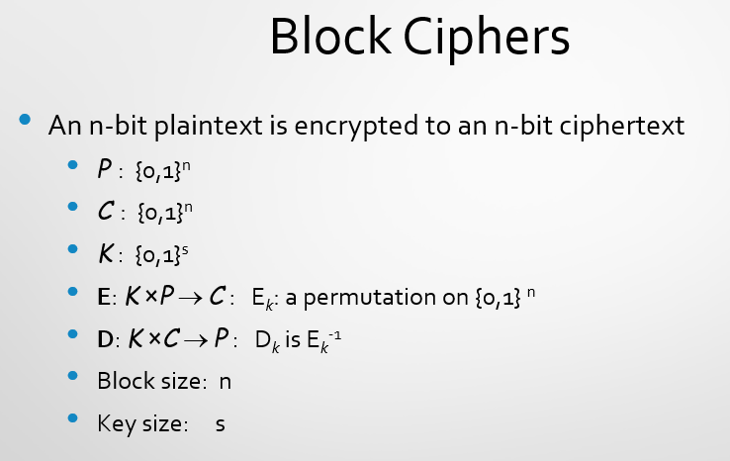
Block Ciphers Continue…
- Most symmetric block ciphers are based on a Feistel Cipher Structure.
- Also known as Feistel/Luby-Rackoff structure.
- In a Feistel cipher, encryption and decryption are very similar operations, and both consist of iteratively running a function called a "round function" a fixed number of times.
- Block ciphers look like an extremely large substitution.
- Would need table of 2⁶⁴ entries for a 64-bit block
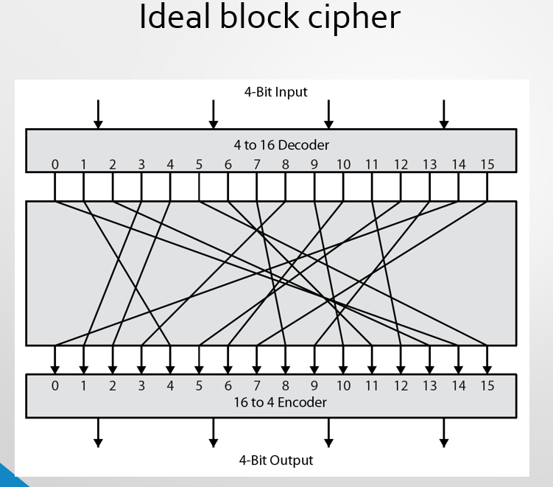
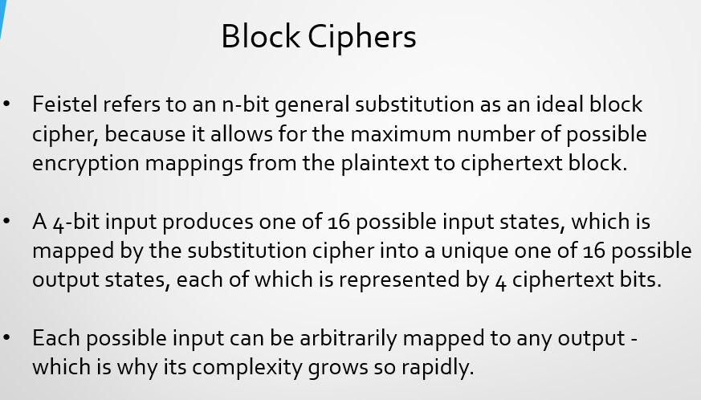
Characteristics:
- Fast
- Data encrypted in fixed “block sizes” (64, 128, 256-bit blocks are common).
- Key and message bits non-linearly mixed in cipher-text.
Feistel Cipher Structure
Horst Feistel devised the Feistel cipher.
Partitions input block into two halves:
- process through multiple rounds which
- perform a substitution on left data half
- based on round function of right half & subkey
- then have permutation swapping halves

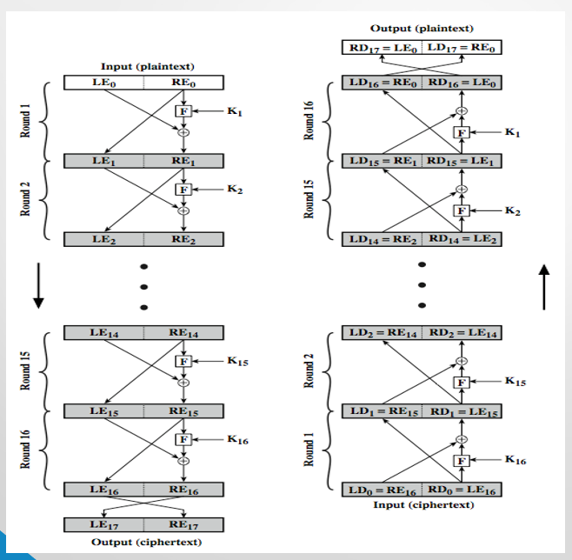

Encryption of Feistel Cipher
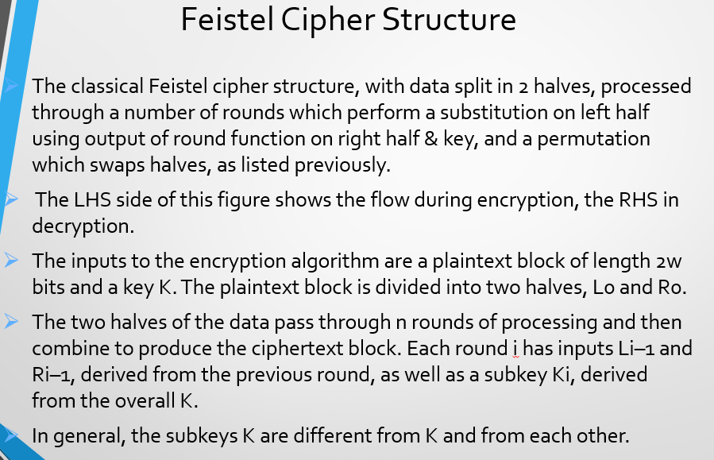
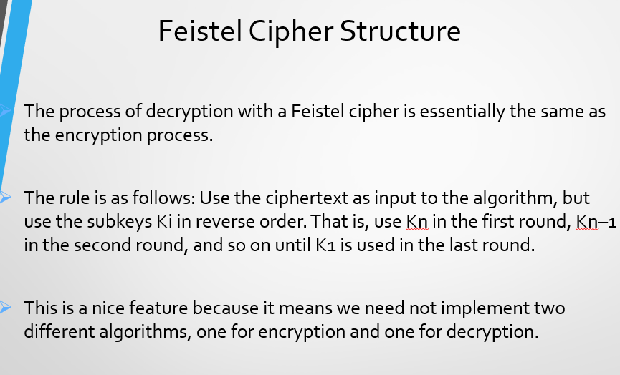
Decryption of Feistel Cipher

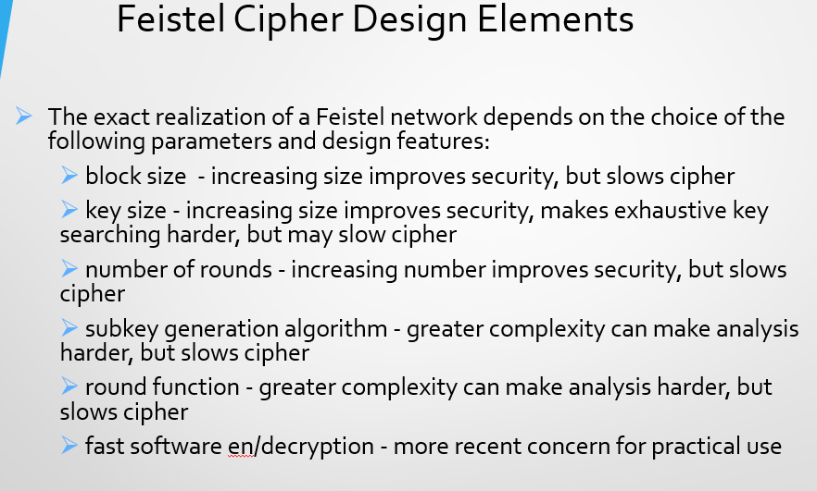
Lecture 09
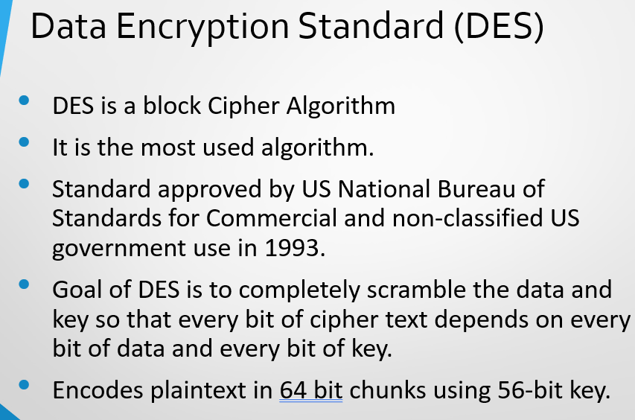
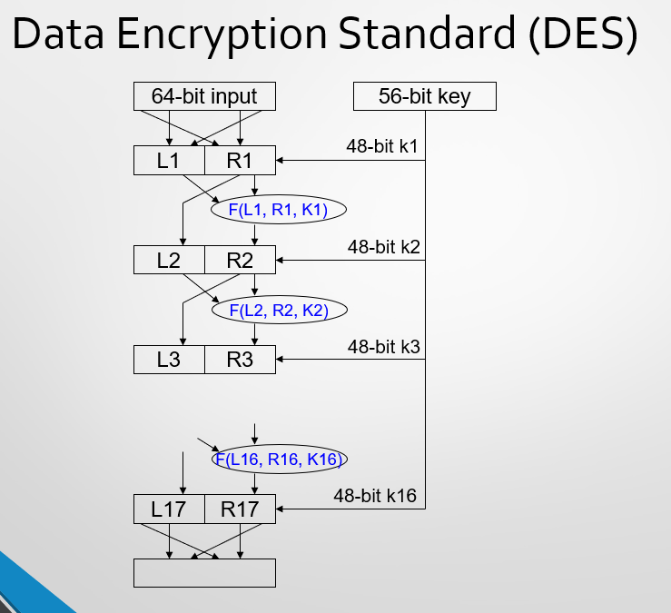

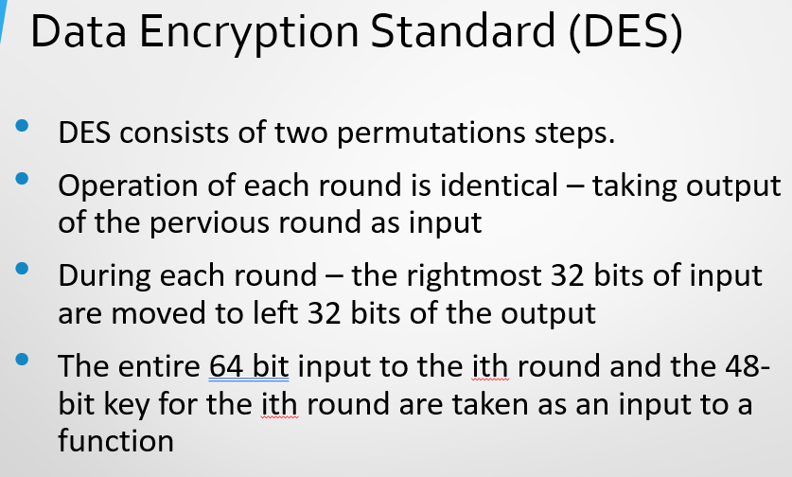

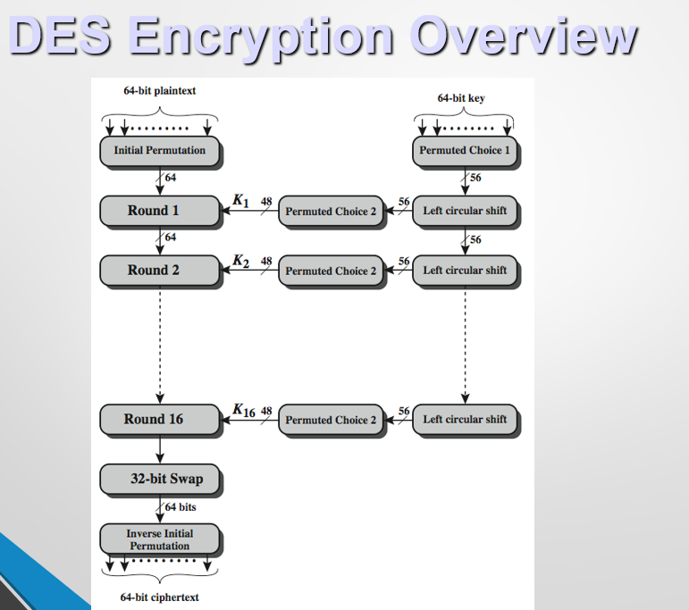
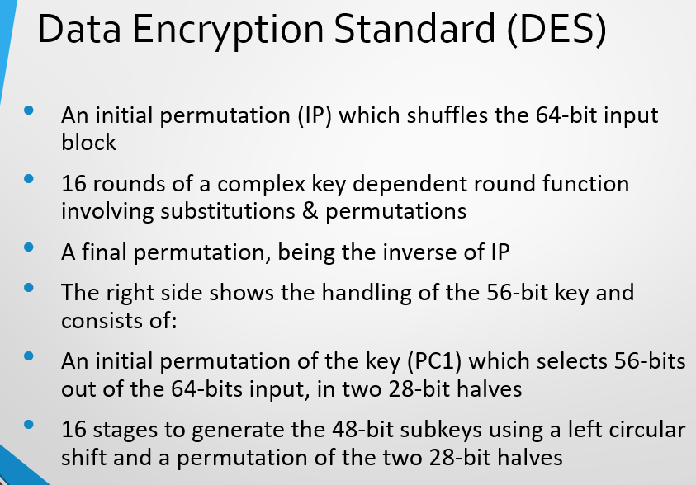

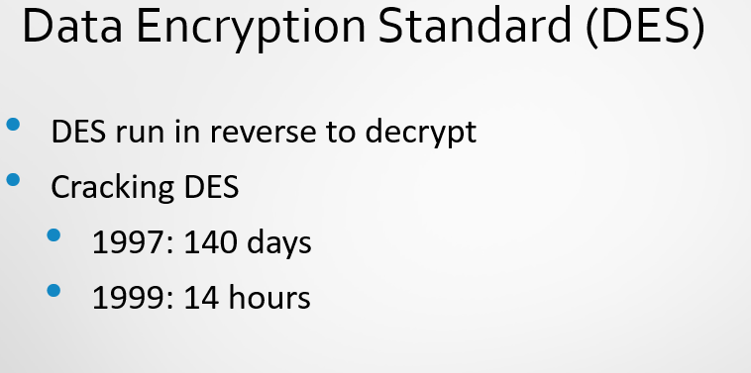
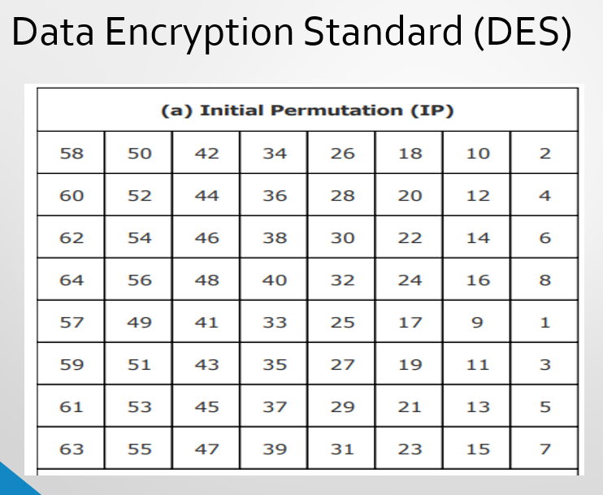

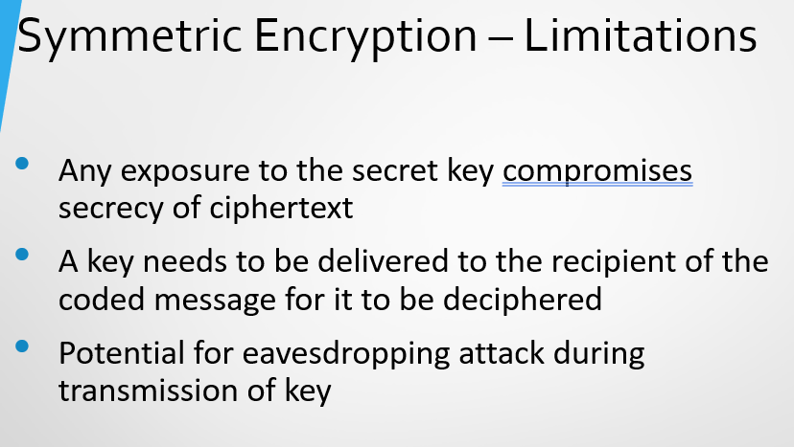
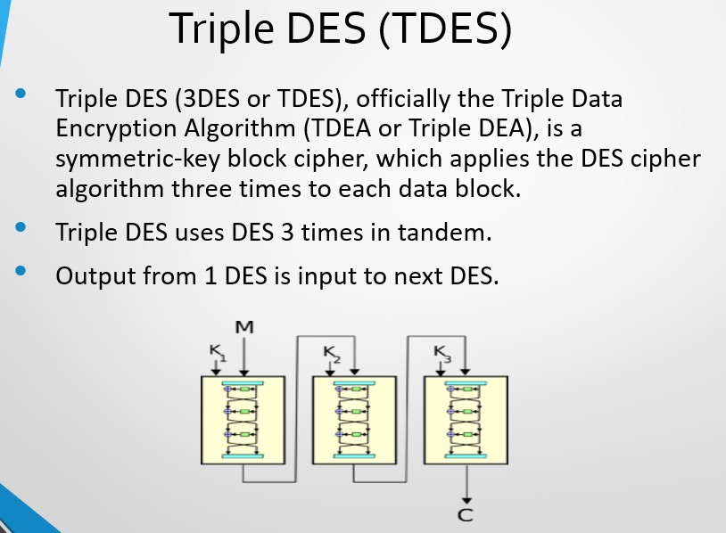
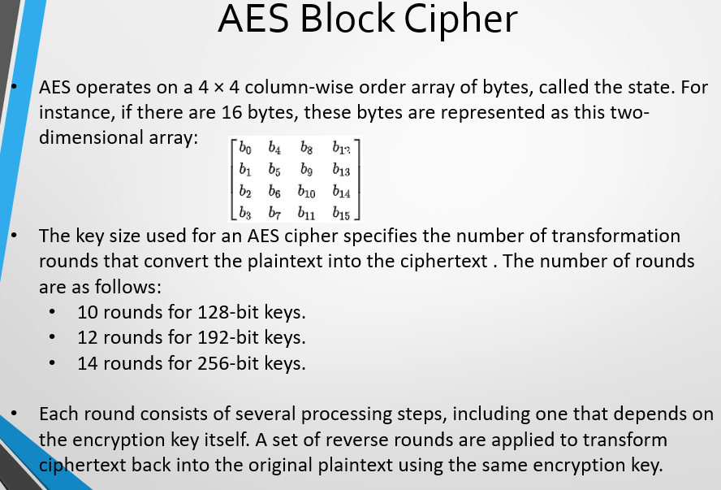
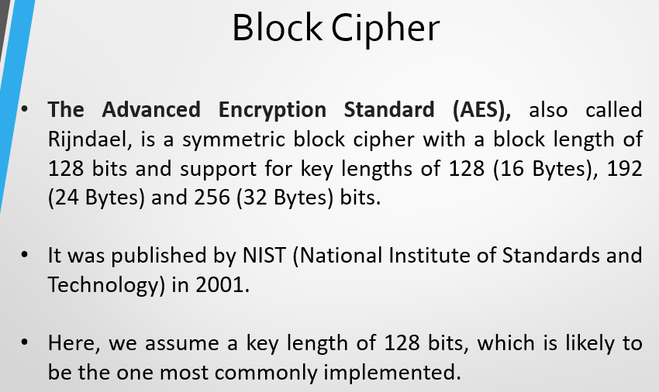
Lecture 10

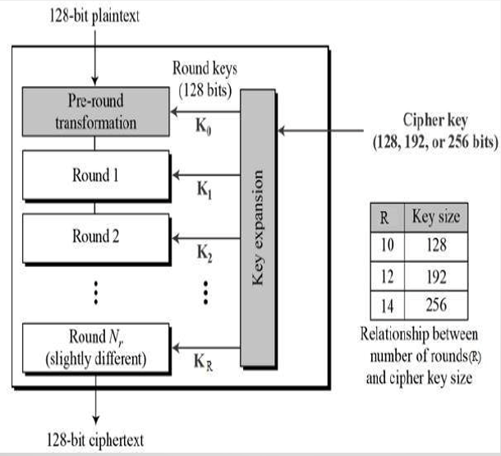

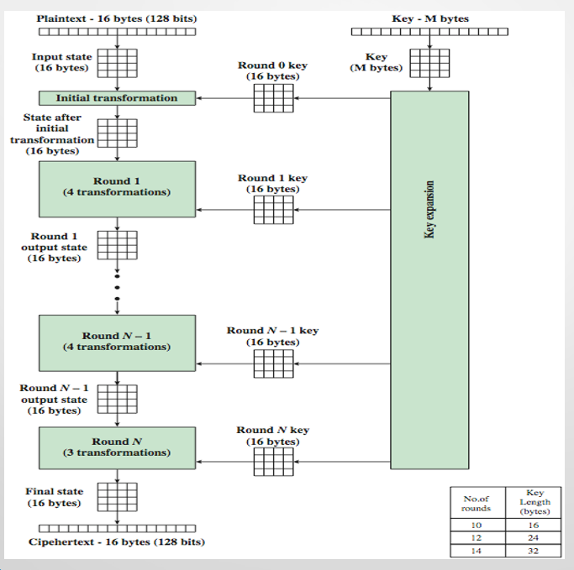

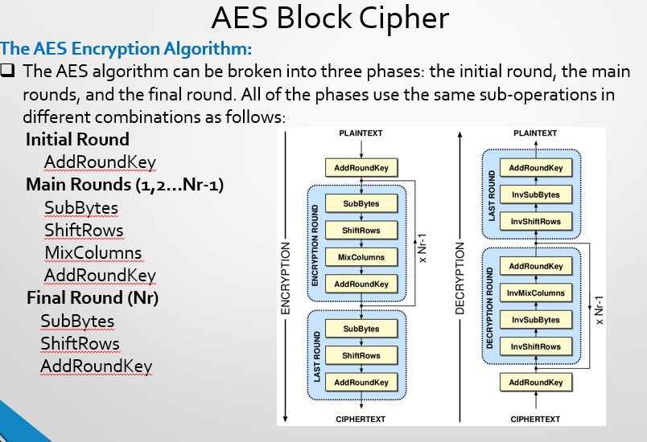
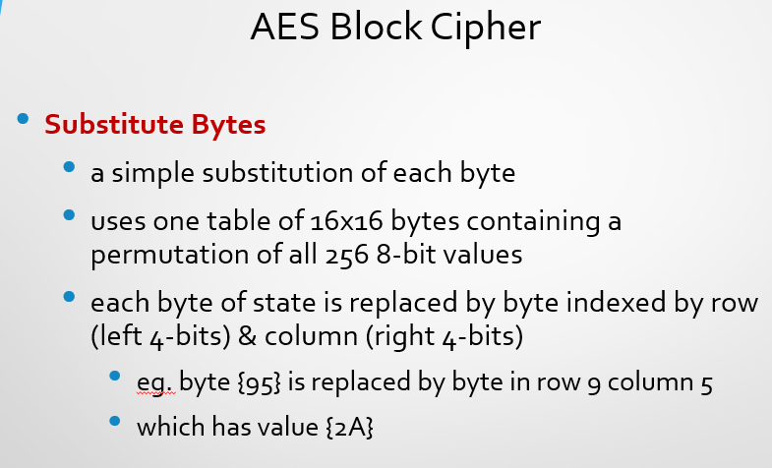
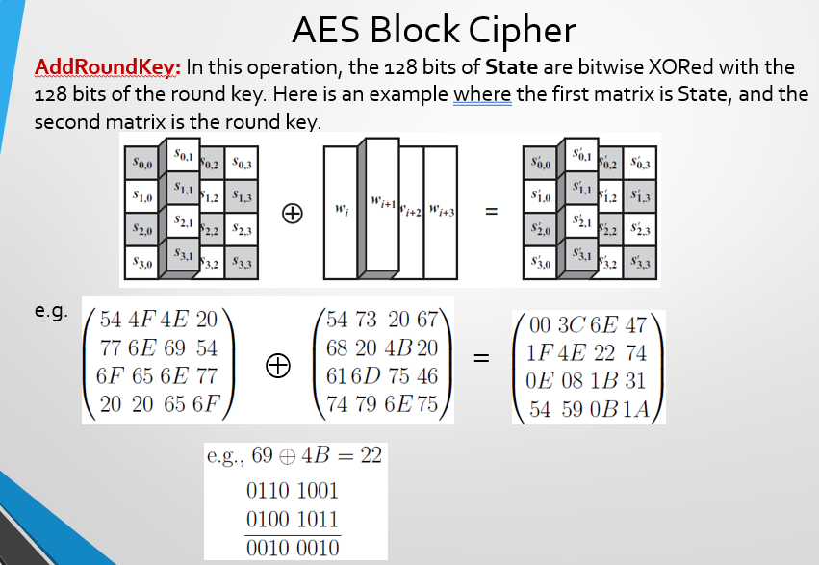
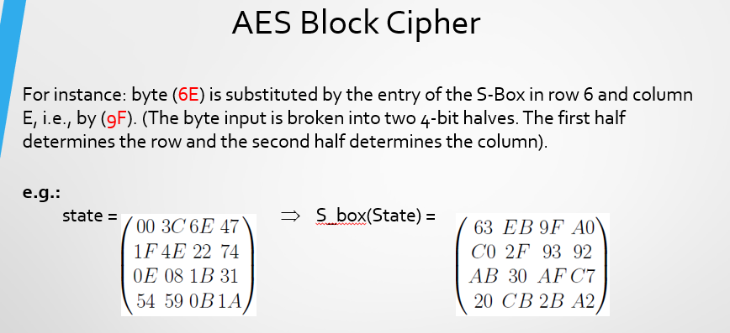
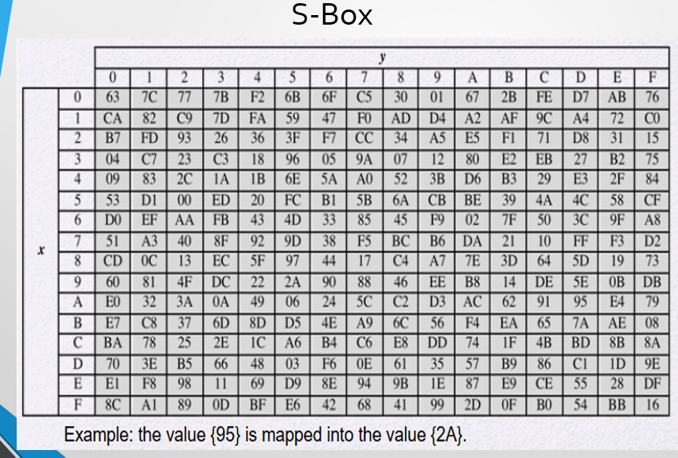

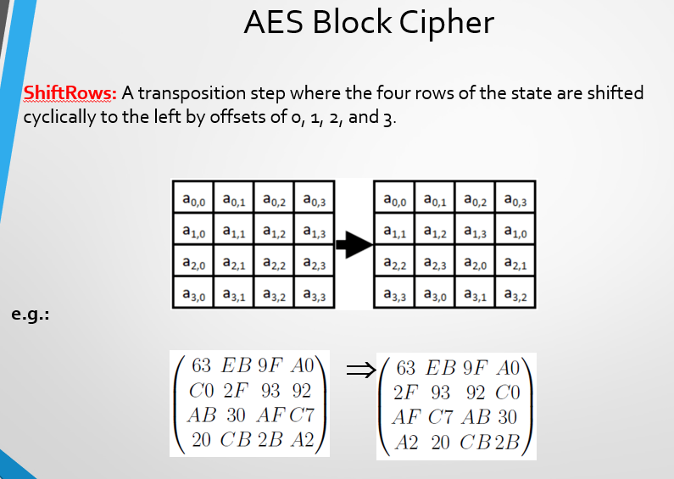
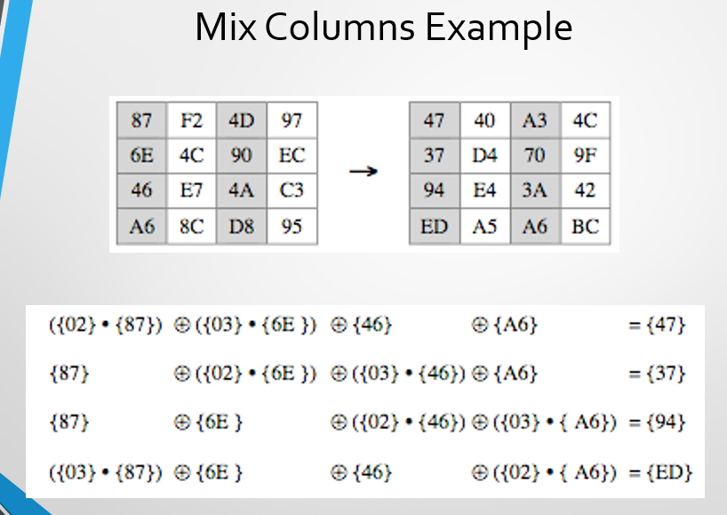
4 Methods of AES
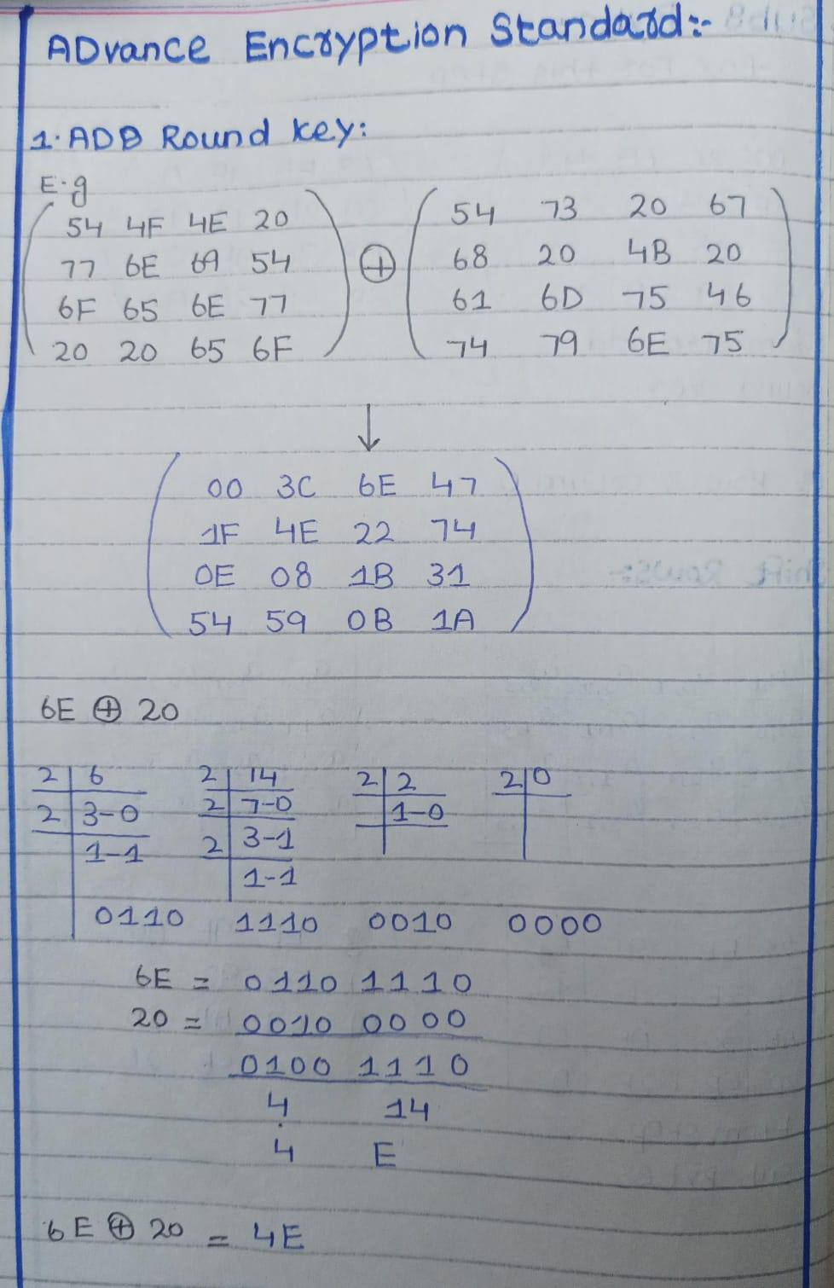
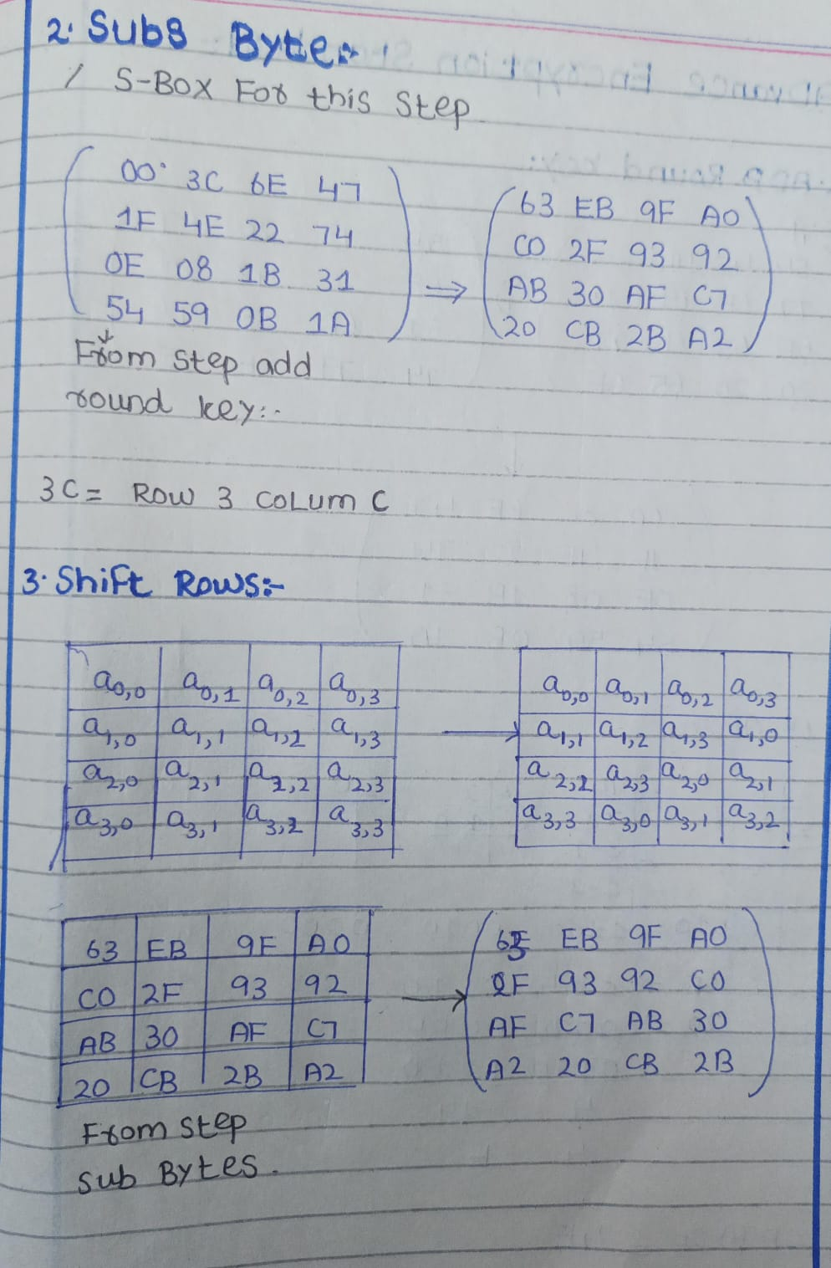
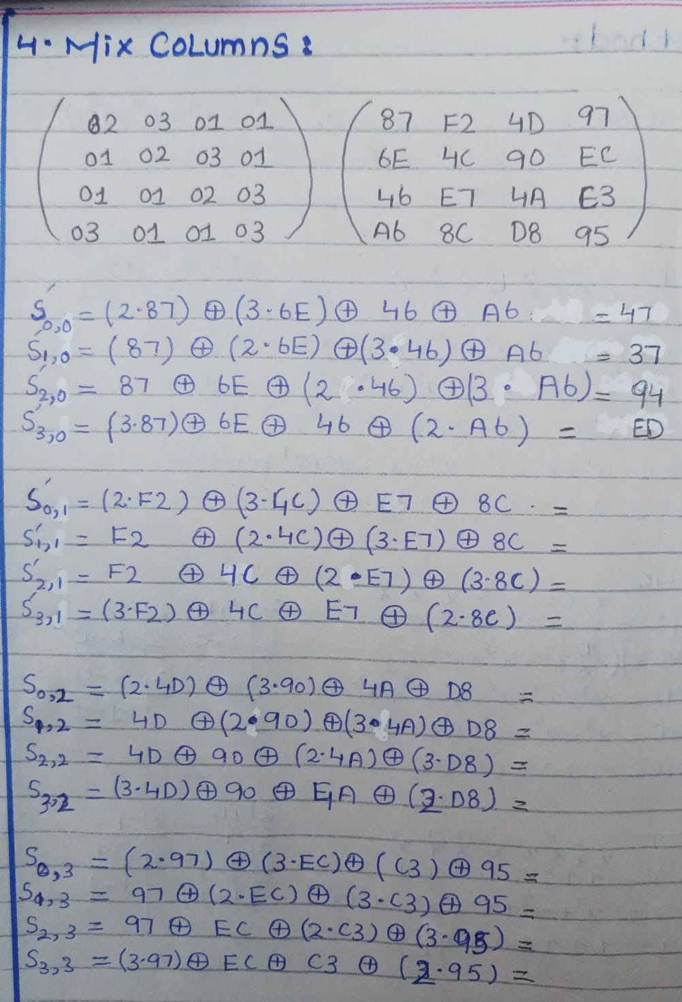
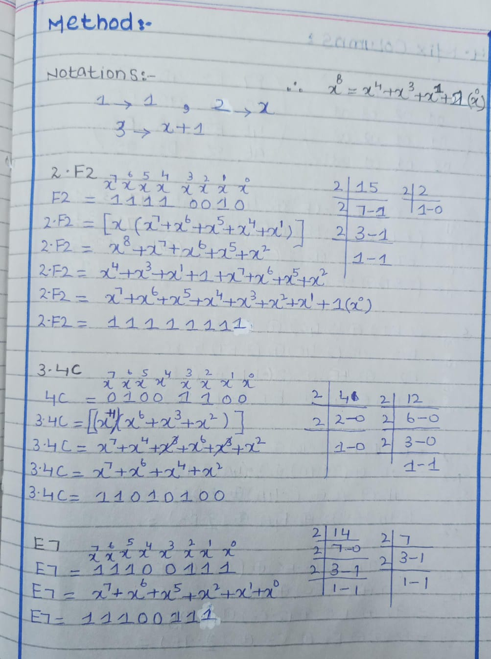
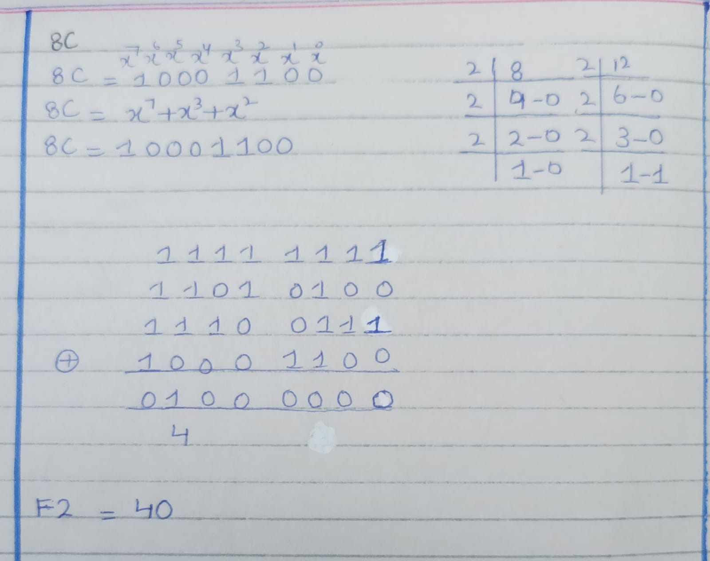

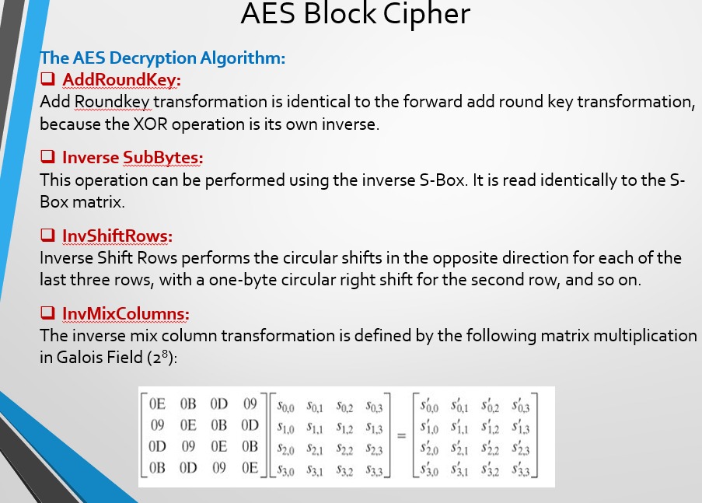

Lecture 11
Encrypting a Large Message: Modes of Operation
Q: What if our plaintext is larger than 128-bit block size?
Electronic Code Book (ECB)
- Splits the plaintext into 128-bit blocks.
- Each block is encrypted independently using the same key.
Issues:
Identical plaintext blocks produce identical ciphertext blocks — this reveals patterns and is insecure for large or structured data.
No integrity checks: can mix and match blocks
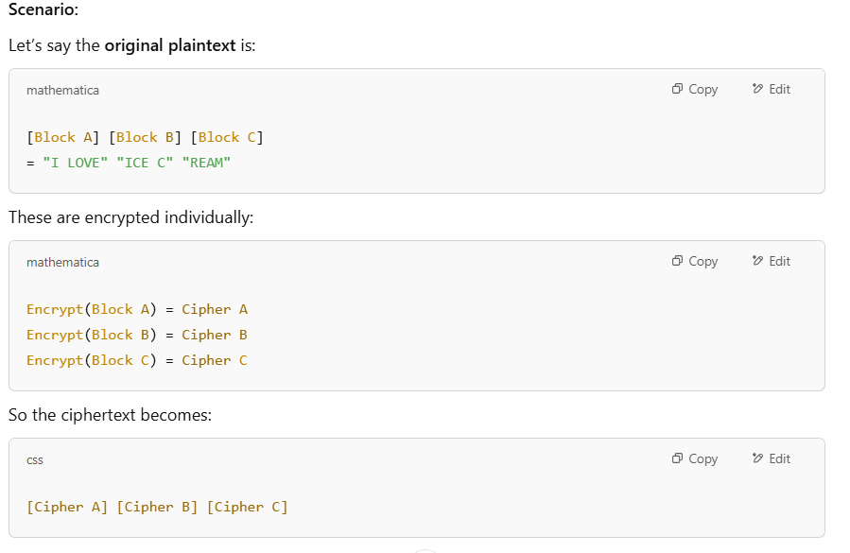
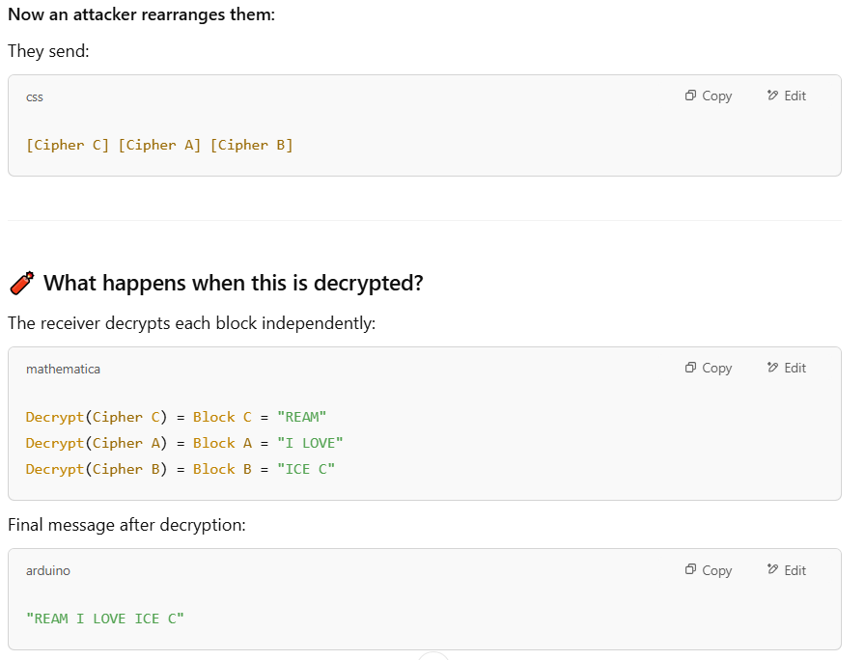
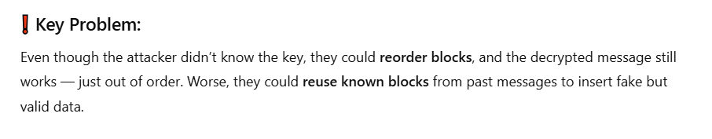
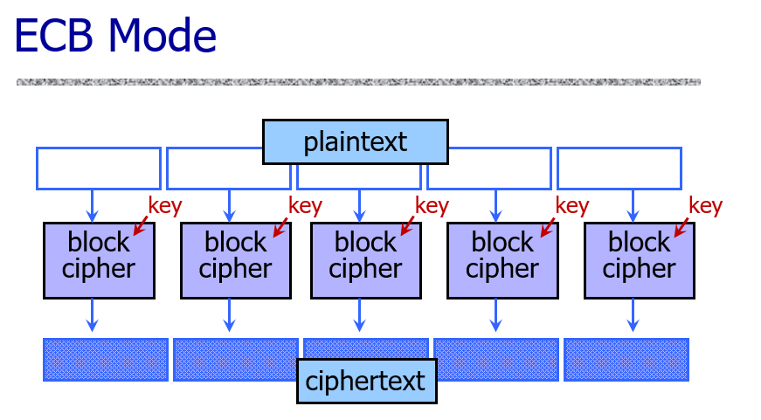
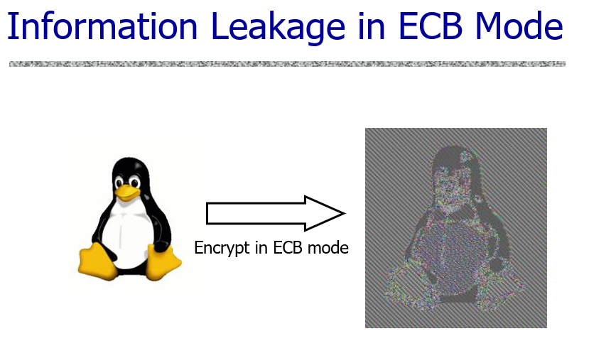
Cipher Block Chaining (CBC)
- Also splits the plaintext into 128-bit blocks.
- The first block is XORed with an initialization vector (IV) before encryption.
- Each subsequent block is XORed with the ciphertext of the previous block, then encrypted.
- This hides patterns better than ECB, making it more secure for larger plaintexts.
Key Points
- Identical blocks of plaintext encrypted differently
- Last cipher-block depends on entire plaintext
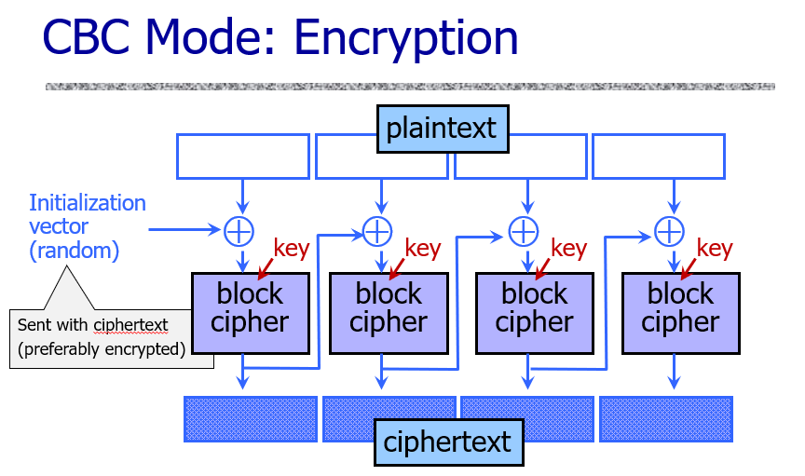

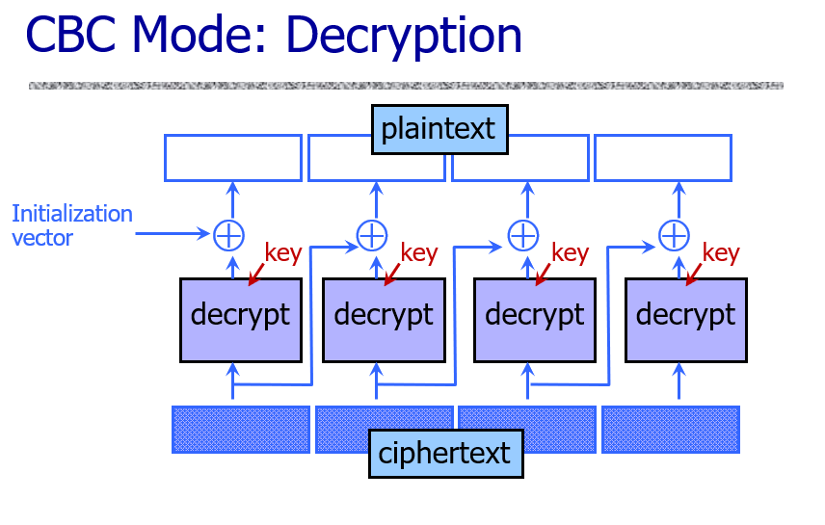
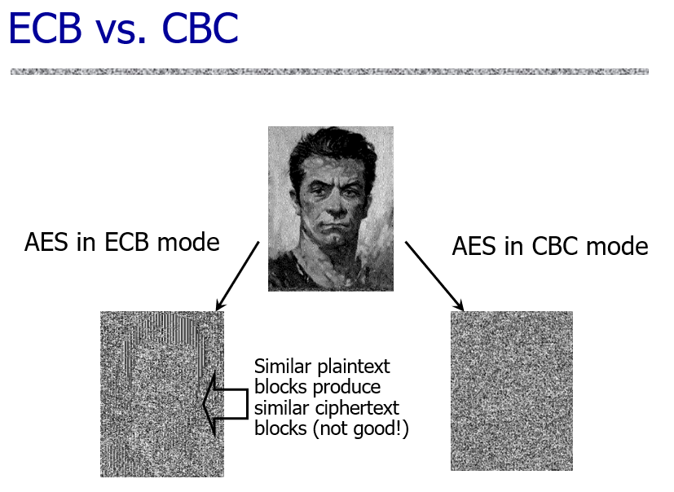
Types of Attack on Encrypted Messages (Cryptanalysis Categories)
1-Ciphertext only attack
A ciphertext-only attack is a situation where the attacker only has access to the encrypted data (ciphertext) — they don’t know the original message (plaintext) or the key used to encrypt it.
Their goal is to:
- Guess the plaintext
- Or find patterns to help break the encryption
This is the hardest type of attack for an attacker because they have very limited information.
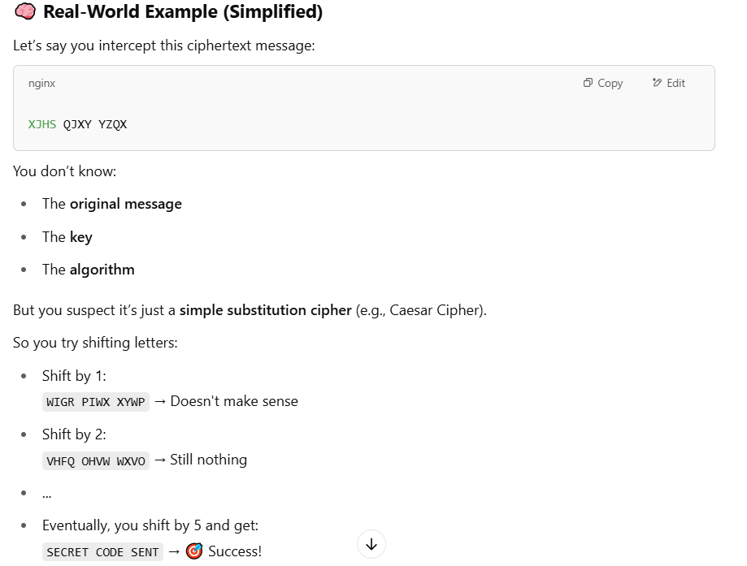
2-Known plaintext attack
A Known Plaintext Attack (KPA) is a type of cryptographic attack where the attacker has access to both the plaintext (the original message) and the corresponding ciphertext (the encrypted message). The goal of the attacker in a KPA is to use this information to deduce the encryption key or the encryption algorithm used.
How Known Plaintext Attack Works:
- Access to Plaintext and Ciphertext: The attacker knows or has a set of plaintext messages and their corresponding encrypted ciphertexts.
- Analyzing the Data: By comparing the plaintext and ciphertext, the attacker may notice patterns or relationships between the two, which could help in determining the encryption key used.
- Cryptanalysis: Once the attacker gathers enough pairs of plaintexts and ciphertext, they may use this data to reverse-engineer the encryption key or break the encryption scheme entirely.
Example:
Let’s take an example where a simple substitution cipher is used (though this is a very basic encryption method, it helps in explaining the concept):
- Plaintext: "HELLO"
- Ciphertext: "KHOOR" (this is an encrypted version using a Caesar cipher with a shift of 3)
Steps in a Known Plaintext Attack:
- Access: The attacker has access to both the plaintext ("HELLO") and the ciphertext ("KHOOR").
- Analysis: By comparing the two, the attacker can see that each letter of the plaintext is shifted by 3 positions in the ciphertext:
  - H → K (shifted by 3)
  - E → H (shifted by 3)
  - L → O (shifted by 3)
  - L → O (shifted by 3)
  - O → R (shifted by 3)
- Cryptanalysis: The attacker notices the shift pattern and deduces that the encryption is based on a Caesar cipher with a shift of 3.
- Key Discovery: The attacker can then use this knowledge to decrypt any other ciphertexts encrypted with the same key (shift of 3) or even deduce that a Caesar cipher is used, which might help in attacking more complex encryption systems.
Chosen Plaintext Attack
A Chosen Plaintext Attack is when a hacker is allowed to pick any message (plaintext) they want and ask the system to encrypt it. They can then see what the encrypted version (ciphertext) looks like. The goal is to use this information to figure out the secret key or how the encryption works.
How It Works:
- Choosing Messages: The attacker selects any messages they want — like "HELLO", "AAA", or anything else — and asks the system to encrypt them.
- Watching the Output: They carefully look at the encrypted versions of those messages.
- Finding Patterns: By comparing the messages they chose and the encrypted results, they try to spot patterns or clues.
- Guessing the Key or Method: Using those patterns, they might be able to guess the secret key or figure out how the encryption is done. Once they do that, they can decrypt other messages that weren’t meant for them.
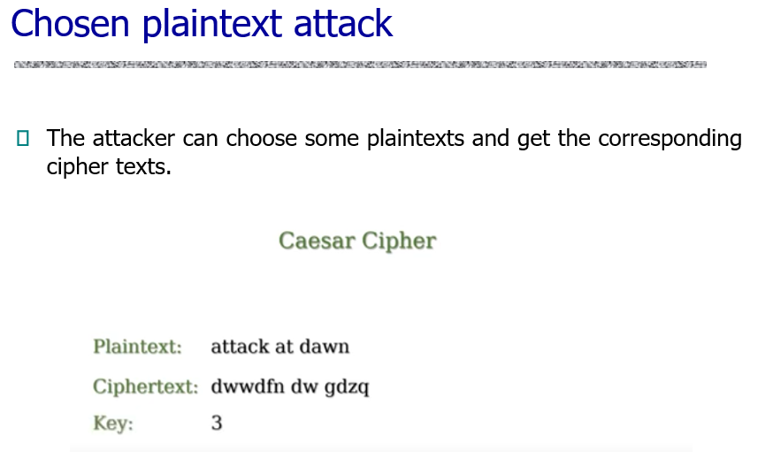

Chosen-Ciphertext Attack
A Chosen-Ciphertext Attack happens when a hacker is able to pick an encrypted message (ciphertext) and somehow find out what the original message (plaintext) was. They do this for several encrypted messages they choose on purpose.
Explanation:
- The attacker chooses some encrypted texts (ciphertexts).
- They find out what the original messages (plaintexts) were for those ciphertexts.
- By doing this many times, they try to learn how the encryption works or even find the secret key.
- Once they know enough, they might be able to read or change other encrypted messages without permission.
Example
Imagine you have a locked message, and you have a magic machine that tells you what’s inside if you put in any locked message. The attacker uses that machine many times, with messages they choose, and learns how the lock works. Then they can open future locked messages by themselves.
Difference from Known-Plaintext Attack:
- In a Known-Plaintext Attack, the attacker already has some message pairs — both the original and encrypted versions — but didn’t choose them.
- In a Chosen-Ciphertext Attack, the attacker picks the encrypted messages themselves and then finds out what they mean.
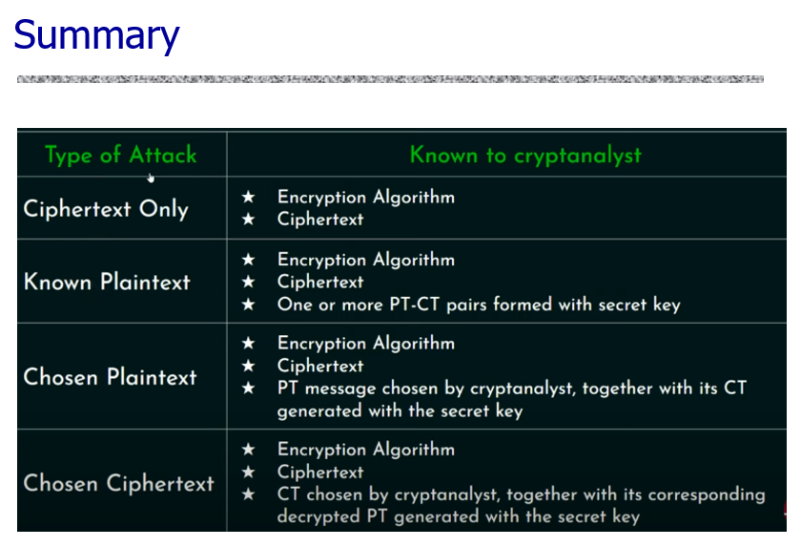
Summary
- A known-plaintext attack is an attack in which the attacker has access to a set of plaintexts and the corresponding ciphertexts.
- A chosen-plaintext attack is an attack in which the attacker can choose some plaintexts and get the corresponding ciphertexts.
- A chosen-ciphertext attack is an attack in which the attacker can gain access to plaintexts of some chosen ciphertexts.
Lecture 12
Malleable
An encryption algorithm is "malleable" if it is possible to transform a ciphertext into another ciphertext which decrypts to a related plaintext.

Example
Let’s say a message m = "Pay $100" is encrypted to ciphertext c.
Now, someone sees c, but they don’t know it means "Pay $100". However, they manage to change c into c′, and when the receiver decrypts it, it turns into:
"Pay $1000"
The attacker never knew the message, but still made it more valuable by changing the ciphertext — this is malleability
Message Authentication
We now consider how to protect message integrity (i.e. protection from modification), as well as confirming the identity of the sender
Message Authentication is concerned with:
- Protecting the integrity of a message: It protects the message from being edited or tampered with.
- Validating identity of originator: It proves the identity of the sender.
- The sender can’t deny they sent it: Once someone sends a message, they can’t say later, “I didn’t send it.”
Nonrepudiation
Nonrepudiation means making sure that someone cannot say they didn’t do something—like signing a document or sending a message. It helps prove that a person really did what they’re claimed to have done, so they can’t later deny it. For example, if someone signs a contract or sends an important message, nonrepudiation makes sure there’s proof they really did it.
Q: Can one deny a signature one has made?
If the signature is properly verified (like a digital or witnessed signature), the person cannot deny it. But if there’s no proof that the signature is really theirs, then yes, they can deny it.
Q: Does email provide non-repudiation?
No, regular email does not provide non-repudiation.
Anyone can deny sending an email because it’s easy to fake or claim someone else sent it. To make email non-repudiable, you need extra tools like digital signatures or secure email systems.
Digital Signatures
- A digital signature is a mathematical scheme for verifying the authenticity of digital messages or documents.
- A valid digital signature on a message gives a recipient confidence that the message came from a sender known to the recipient.
- A signer publishes a public key pk
- To sign a message m, the signer uses its private key to generate a signature σ
- Anyone can check if the signature (σ) is real by using the signer’s public key.
- But only the signer has the private key needed to create that signature.
So, if the signature is valid, it proves that the signer approved (or “certified”) the message.
Security:
No one else can create a real signature except the true signer—because only they have the private key.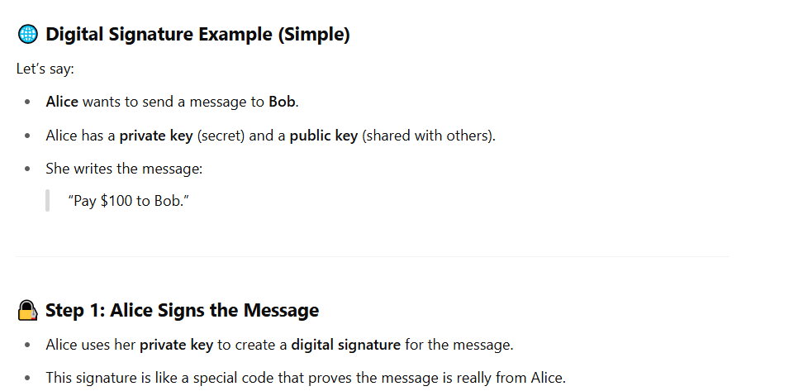
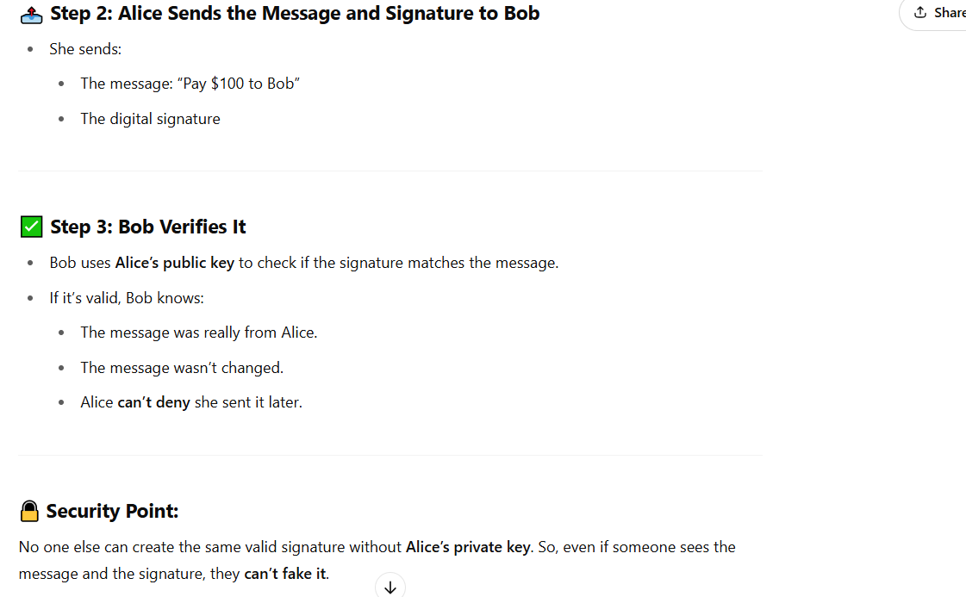

Message Authentication Code (MAC)
A MAC is a short code added to a message to make sure it is real and hasn't been changed.
It is made using a special formula (algorithm) that takes:
- The message
- A secret key shared between the sender and receiver
- like encryption, though need not be reversible
The result is a small block of data called the MAC.
How it works:
- The sender creates a MAC from the message and secret key.
- The MAC is sent along with the message.
- The receiver uses the same key and formula to create their own MAC.
- If both MACs match, the message is authentic and unchanged.
What MAC ensures:
- The message was not changed.
- It was sent by someone who knows the secret key.
……………………………………………………………………………………………………………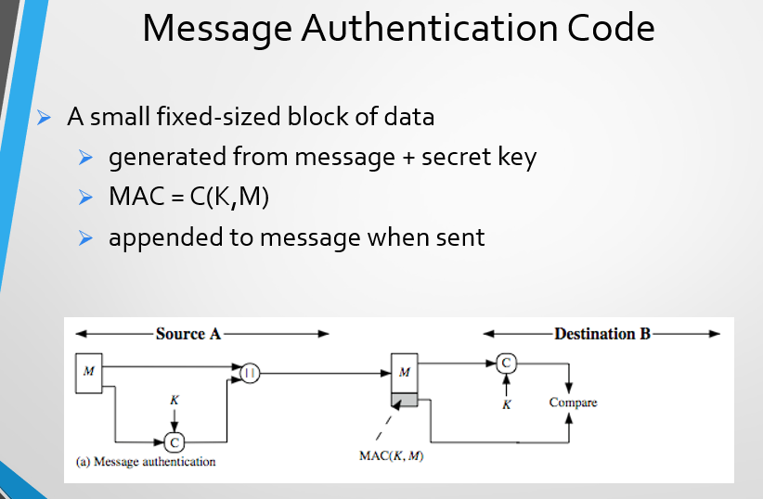
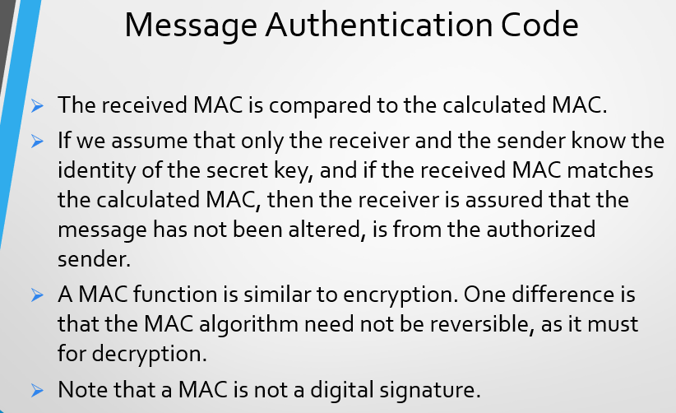
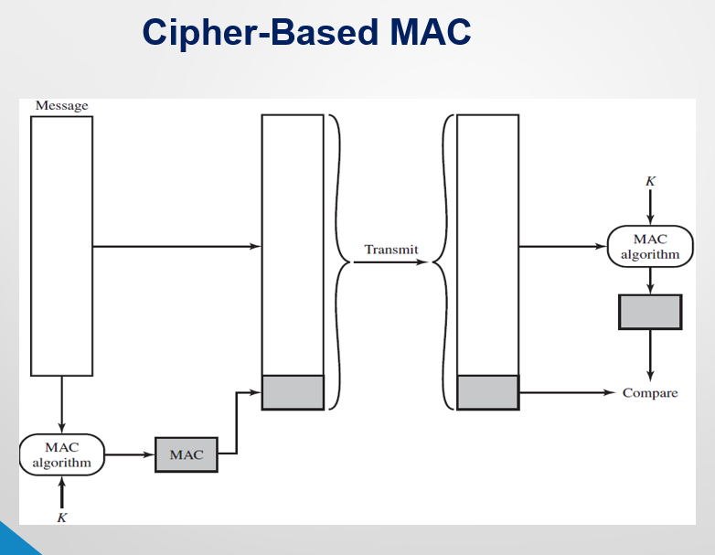
Digital Signature Forgery
In a digital signature or MAC system, forgery means someone creates a fake message and signature that looks real—even though the real sender never made it.
Existential Unforgeability
This means an attacker should not be able to create any valid signature for any new message that the real sender didn't actually sign.
Even if it's a small or random message, if it wasn’t signed by the sender, it shouldn’t be possible to fake it.
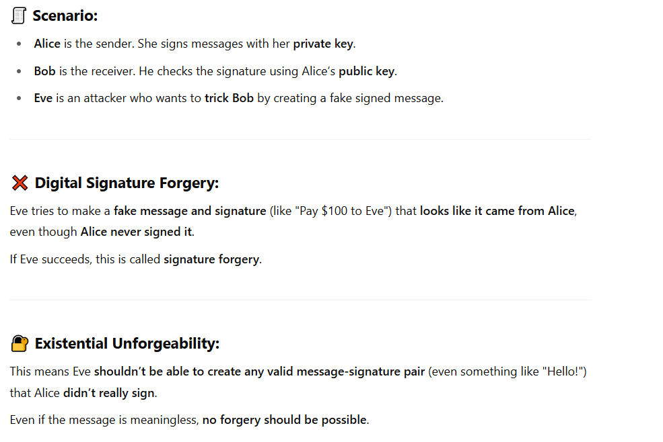
Lecture 13
Authenticated Encryption (AE)
Authenticated Encryption (AE) is a method that protects your data in two important ways at the same time:
- Confidentiality – It hides the message so that no one can understand it without the secret key.
- Authenticity – It also proves that the message is real and hasn’t been changed, by adding a special code (called an authentication tag) that only someone with the secret key can create.
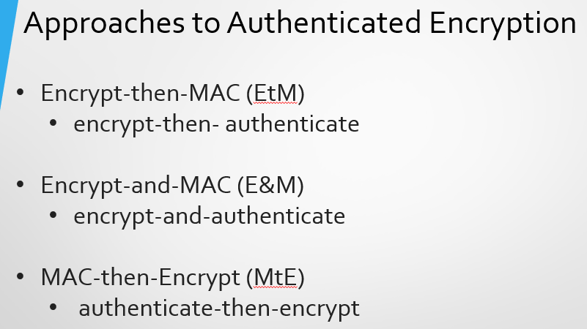
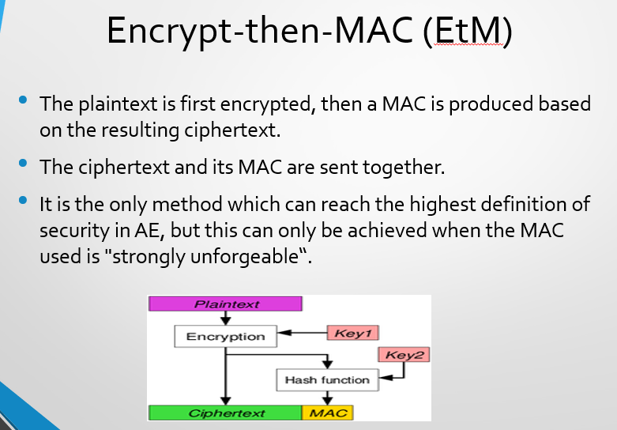
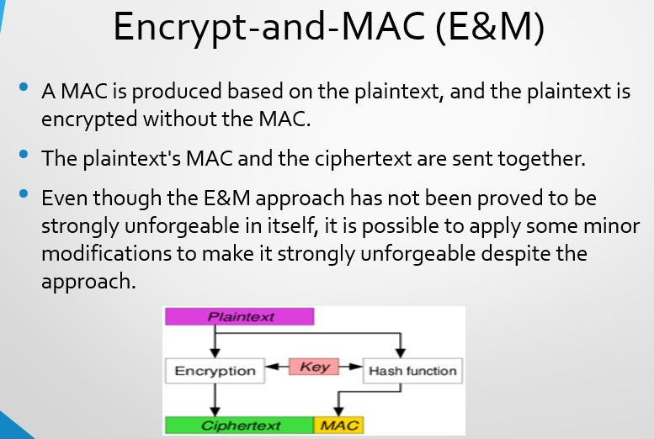
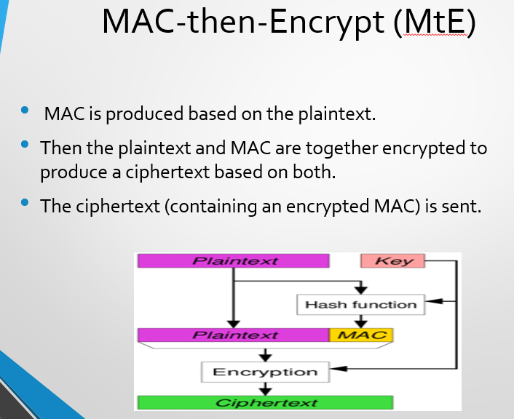
Oracle Attack
In security engineering, an oracle attack is when a hacker takes advantage of a system that gives simple feedback — like "yes" or "no", or "correct" or "wrong" — in response to their attempts.
Even though this feedback seems small, the attacker can keep trying different inputs and use the system’s responses to slowly figure out the secret information (like a password or encrypted data).
Example
Imagine a locked box with a 4-digit code. You don’t know the code, but every time you try a code, the box says:
- "Correct digit in the correct place"
- "Wrong digit"
Even though it doesn’t give the code directly, this little hint helps you try different numbers and get closer and closer to the right code.
What is a Padding Oracle Attack?
In cryptography, messages are often padded (extra bytes are added) so they fit the block size required by encryption algorithms (like AES).
A padding oracle attack happens when:
- A system tells the attacker whether the padding is right or wrong after trying to decrypt a message.
- The attacker uses this small info to slowly figure out the real, secret message (even without the key!).
Example:
You’re trying to open a treasure box (encrypted message), and the box gives one of two responses every time you try:
- “Padding is correct.”
- “Padding is incorrect.”
You can’t see the actual message inside, but this tiny hint helps you test different versions of the message and find out what the original message was.
Advantage for Attacker
It tells the attacker not to waste the time (Applying different Encryption Algorithms) where the padded has been done by the sender.
Lecture 14
What ciphers do?
Encryption ciphers
- Provide confidentiality
- Eve can’t see what Alice and Bob are saying
- Can Eve do anything?
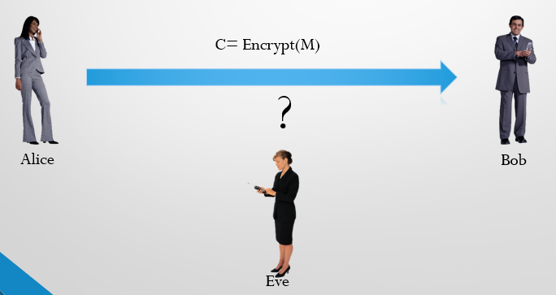

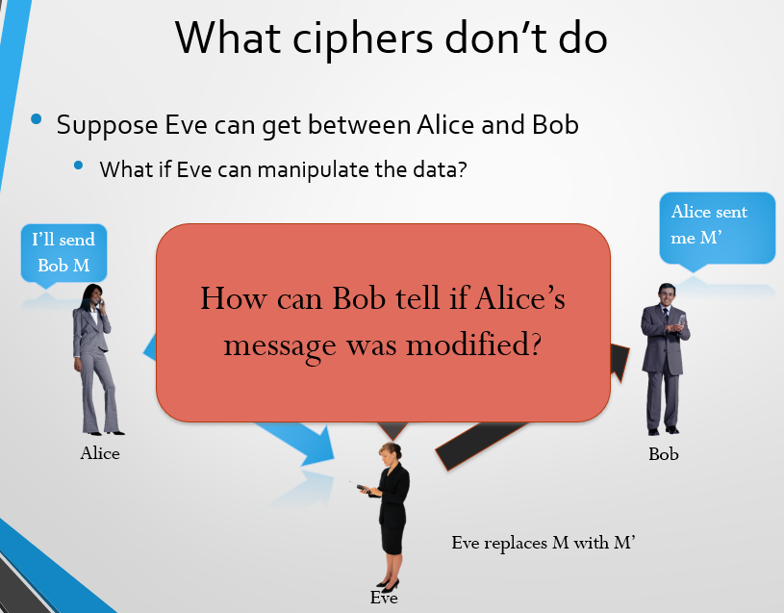
Hash Functions vs. Digital Signatures
A hash function and a digital signature are both cryptographic tools used for ensuring data security, but they serve fundamentally different purposes and have distinct characteristics.
Digital Signature
Purpose: Used to ensure data integrity, authenticity (verifying the sender's identity), and non-repudiation (preventing the sender from denying they sent the message).
Process: Involves two keys in an asymmetric (public-key) cryptosystem:
- Private Key: Held securely by the sender and used to create the digital signature of a message (often after the message has been hashed).
- Public Key: Freely distributed and used by the receiver to verify the digital signature.
Hash Function
Purpose: A hash function is mainly used to check if data has been changed. It creates a special code (called a hash, digest, or message fingerprint) from the original data. If even a small change happens in the data, the hash will also change — so you can tell something is wrong.
Process: Takes an input of any size and produces a fixed-size output. This process is one-way, meaning it's computationally infeasible to reverse the hash to find the original input.
Hash Function: Security Properties
- One-way: Hard to find the original message from its hash.
- Collision Resistance: Hard to find two different messages that produce the same hash.
- Analogy: Think of a fingerprint for a document. If even a single character in the document changes, the fingerprint (hash) will be completely different, indicating tampering
Hash Function Continue…
- A Hash function (H) accepts a variable-length block of data M as input and produces a fixed-size hash value h = H(M).
- A “good” hash function has the property that the results of applying the function to a large set of inputs will produce outputs that are evenly distributed and apparently random.
- In general terms, the principal object of a hash function is data integrity.
Cryptographic Hash Function
A cryptographic hash function is a special formula that:
- Makes it very hard to find the original data just by looking at the hash code. (This is called the one-way property.)
- Makes it very hard to find two different pieces of data that create the same hash code. (This is called the collision-free property.)
Because of these features, we use hash functions to check if data has been changed or not.
Applications of Cryptographic Hash Functions
Message Authentication
It’s a way to check that a message hasn’t been changed in any way.
This means the message you get is exactly the same as the one that was sent — nothing added, removed, or changed.
One-way Password File
Instead of saving your actual password, the system saves a hash (a special code) of your password.
When you type your password, the system makes a hash of it and checks if it matches the saved hash to see if you’re correct.

Intrusion and Virus Detection
The system saves a hash value for each important file.
Later, it checks the file again by making a new hash and comparing it to the saved one.
If the hash is different, it means the file was changed.
For an intruder to avoid being caught, they’d have to change the file without changing the hash, which is very hard.
Popular Hash Functions
Message Digest (MD):
MD5 was most popular and widely used hash function for quite some years. The MD family comprises of hash functions MD2, MD4, MD5 and MD6. It is a 128-bit hash function. In 2004, collisions were found in MD5 and hence it is no longer recommended for use. MD6 did not achieve widespread adoption.
Secure Hash Algorithm (SHA):
It is the most widely used hash function. SHA was developed by NIST and published in 1993. It has several versions such as SHA-1, SHA-256, SHA-512,..etc.
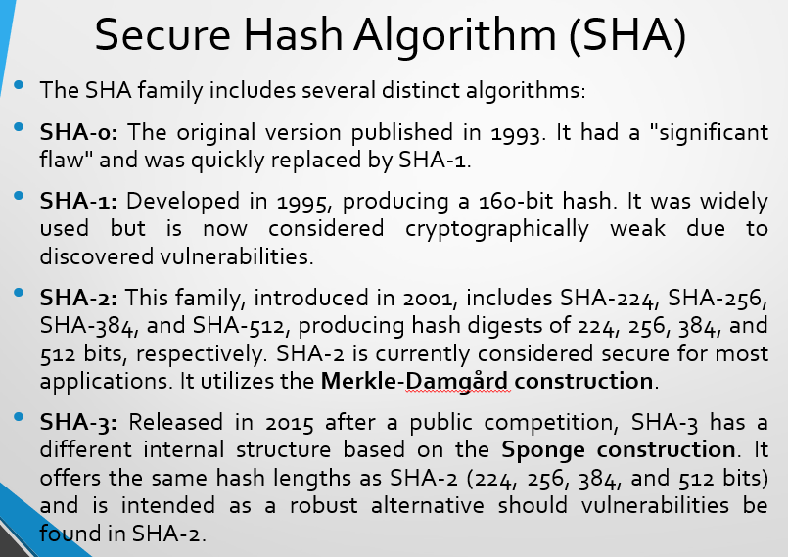
Lecture 15
Merkle-Damgård construction
- The Merkle-Damgård construction is a simple and important method used in cryptography to build strong hash functions. It takes a small, secure building block (called a compression function) and uses it over and over to create a full hash function that can handle data of any size.
- It was developed separately by Ralph Merkle and Ivan Damgård.
- Many popular hash algorithms like MD5, SHA-1, and SHA-2 use this method. The goal is to make sure that if the small building block is hard to break (collision-resistant), then the whole hash function is also hard to break.
- It is based on CBC mode. (Not exactly same as CBC mode but it follows that approach)
Continue...
- Padding:
The message is made longer (if needed) by adding extra bits. This is done so that its total size becomes a multiple of a certain block size. Padding often includes the length of the original message at the end.
- Initialization Vector (IV):
The process starts with a fixed starting value, called the IV. Think of it like the first "seed" for hashing.
- Splitting into Blocks:
The padded message is broken into equal-sized parts (blocks) — like M1, M2, ..., Mn.
- Compression Function (Iterative Process):
A special function (called a compression function) processes each block one by one.
- It takes the current block and the previous result.
- It mixes them and produces a new result.
- This new result is passed on to the next round with the next block.
- Final Hash Value:
After all blocks are processed, the final output is the hash value. This is the fingerprint of the original message.


Sponge Construction
What is it?
The Sponge construction is a method used in cryptography to create hash functions that can:
- Take input of any length
- Give output of any desired length
How does it work?
It uses a fixed-size internal state (think of it like a sponge that soaks and squeezes data) which is split into two parts:
- Rate (r): The part where data goes in and comes out (input/output)
- Capacity (c): The hidden part that adds security (never directly seen)
Steps:
- Absorb:
It takes the input data piece by piece and mixes it into the state.
- Squeeze:
After all the input is absorbed, it starts producing output from the state.
Where is it used?
The SHA-3 family of hash functions (like SHA3-224, SHA3-256, etc.) is based on this construction.
Why is it called a "sponge"?
Because it first absorbs the input and then squeezes out the output—just like a real sponge!
Example to understand above steps
Imagine a sponge that can hold 10 drops of water in total (this is the state size).
Now, this sponge is split like this:
- Rate (r) = 6 drops
- Capacity (c) = 4 drops
Step 1: Absorbing (Input stage)
Let’s say you have a message made of 12 drops of water (input bits).
The sponge takes in 6 drops at a time (because rate = 6), and mixes them inside with the capacity.
- First 6 drops go in mixed inside the sponge
- Then the next 6 drops go in again mixed
Step 2: Squeezing (Output stage)
Now you want a hash output — the sponge starts squeezing out 6 drops at a time (rate = 6). If you want more output, it will mix the inside again and squeeze out more.
To Under stand the rate and capacity
Imagine the sponge (the internal state) can hold 10 drops in total.
- Rate = 6 drops this is the part used for input/output.
You can send in or get out 6 drops at a time.
- Capacity = 4 drops this is not used for sending in or getting out drops. It just stays inside, hidden, and makes the system more secure.
Continue…
1.Padding: The input message is padded using a specific rule.
2. Absorbing Phase:
- The padded input is divided into blocks of a fixed size (the 'rate', denoted as r).
- Each block is XORed into the first r bits of the state.
- After each XOR, a fixed permutation function (Keccak-f) is applied to the entire state (of b bits, where b=r+c, and c is the 'capacity').
3. Squeezing Phase: Once all input blocks are processed, output is generated by taking the first r bits of the state.
- After each r-bit block of output is extracted, the Keccak-f permutation is applied to the state again.
- This process continues until the desired output length is reached.
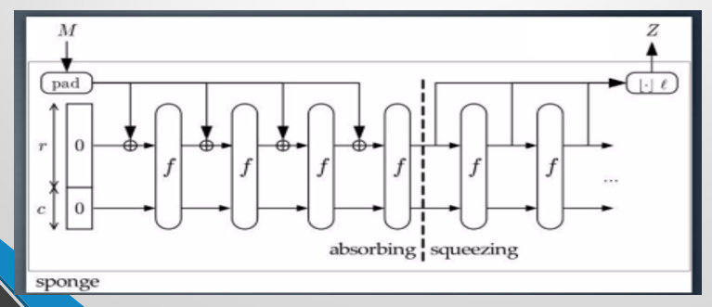
Lecture 16
Blockchain Technology
- A digital ledger (Record Book) of transactions
- Decentralized and distributed across many computers
- Ensures transparency, security, and immutability (unchangeable)
What actually Transparent Mean
- When someone writes something in it (like a transaction), everyone can see it.
- But no one can secretly erase or change it.
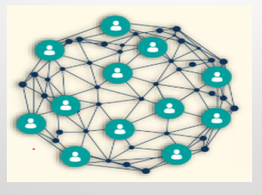
Key Characteristics
- Decentralization: No boss — the system is run by many computers around the world, not just one.
- Transparency: Everyone can see the records — nothing is hidden.
- Immutability: You can't change the past — once something is written, it's permanent.
- Security: It’s protected — special coding (called cryptography) keeps it safe from hackers.
- Consensus: Everyone must agree — before adding a new transaction, all computers check and approve it.
How Blockchain Works
- Someone asks to make a transaction
- The transaction is sent to many computers in the network
- Computers check if the transaction is real and correct
- Approved transactions are put together in a group called a block
- The block is added to the chain of past transactions
- All computers update their records with the new information

Blockchain Types:
Public Blockchain
- Anyone can join, see, and participate (e.g., Bitcoin, Ethereum).
- It’s fully open and decentralized.
Private Blockchain
- Only certain people or organizations can join and participate (e.g., Hyperledger).
- Used mainly by businesses for privacy and control.
Consortium Blockchain
- Controlled by a group of organizations, not just one.
- Only approved members can participate and validate transactions.
Hybrid Blockchain
- Combines features of both public and private blockchains.
- Some parts are open to everyone, while others are restricted.
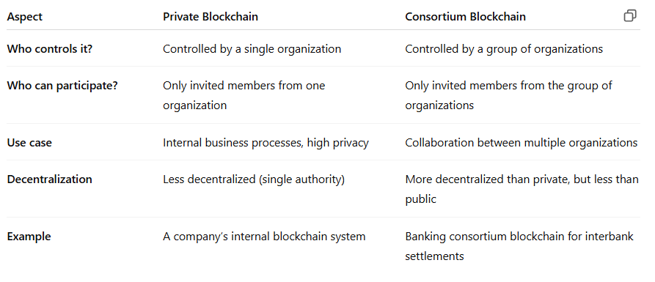

Applications of Block Chain
Cryptocurrencies
- Digital money like Bitcoin and Ethereum that use blockchain for secure transactions.
Supply Chain Tracking
- Tracking products from origin to delivery to ensure transparency and reduce fraud.
Healthcare Data
- Securely storing and sharing medical records while protecting patient privacy.
Voting Systems
- Making elections transparent and tamper-proof by recording votes on a blockchain.
Financial Services
- Faster, cheaper, and more secure banking, payments, and insurance processes.
Advantages
Reduced fraud
- Transactions are secure and hard to fake or change.
Improved traceability
- You can easily track where things come from and where they go.
Enhanced security
- Data is encrypted and stored across many computers, making hacking very difficult.
Faster and cheaper transactions
- When you send money or make a deal, usually a middleman (like a bank or company) helps process it.
- Because blockchain lets you send money or info directly to the other person, it’s faster and costs less (no middleman fees or delays).
Automation via smart contracts
- A smart contract is a computer program on the blockchain.
- It automatically does things when certain rules are met — for example, paying a seller only after you receive the product.
- This means no one has to check or approve manually; the contract handles it all by itself, saving time and effort.
Limitations
Scalability Issues
Most blockchains, like Bitcoin and Ethereum, can only handle a limited number of transactions at once. When many users join, the network slows down and transaction fees go up.
Energy Consumption
Some blockchains use energy-heavy methods such as Proof of Work, which require huge computing power and consume a lot of electricity, causing environmental concerns.
Data Immutability
Once data is recorded on the blockchain, it cannot be changed or deleted. This makes the system secure but also means mistakes or illegal data stay permanent unless a complicated update called a fork happen
Fork: A fork happens when a blockchain’s rules are changed, creating two separate versions of the chain. This can occur to add new features or when there’s a disagreement among participants about how the blockchain should work.
Lecture 17
Key Distribution
- In symmetric encryption, both people (sender and receiver) must use the same secret key to send and read messages.
- The main problem is: How can they share this secret key without someone else (a hacker) finding out?
- The hardest part of secret communication is not the coding — it’s safely sharing the key.
- Most hackers don’t break the code — they find weaknesses in how people share or store the keys.
Ways to Share Secret Keys (for A and B)
1. A gives the key directly to B (in person)
- A can hand over the key to B physically.
- Safe for small groups.
- Not practical for big groups or people far away.
- For example: If there are 100 people, how many keys do we need?
2. A third person gives the key to both A and B
- A trusted third party gives the same key to both A and B.
- Same as above, works for small numbers.
- It’s hard to find someone who’s 100% trustworthy and available.
3. A and B use an old key to send a new one
- If A and B already shared a key before, they can use it to send a new secret key.
- Works well once secure connection is made.
- Still need a way to share the first key securely.
Example:
- Key (old codeword): “Pineapple”
- Message: “The new key is Grapes”
- You lock the message using “Pineapple” (the key)
- Friend uses Pineapple to unlock and read the message
4. A and B ask a trusted third party (C) to send the key
- If both A and B trust someone like C, they can let C send the key to both.
- Smart and scalable method.
- Only works if both A and B already trust C and have secure connections with C.
Main Difference:
- Option 2: Key is shared physically.
- Option 4: Key is shared securely over a network, using existing trust and secure links with a third party
Needham-Schroeder Symmetric Key Protocol
What it is?
It's a method that uses symmetric encryption — this means both people use the same secret key to talk secretly.
But instead of giving the key directly, it uses a Trusted Helper called the KDC (Key Distribution Center) to help share keys safely.
Sessions keys: A session key is a temporary secret key used for one communication session between two parties. It keeps the conversation private and secure during that session only.
Who's involved?
- A = Person 1
- B = Person 2
- KDC = Trusted Key Distribution Center
Goals of the Protocol
1. Authenticate parties:
Make sure that the two people talking are really who they say they are — no fake or bad guys pretending to be them.
Real-Life Example: Secret Club Meeting
Imagine Alice wants to join a secret club meeting with Bob, but they don’t know if the other person is really part of the club. They both trust the Club Manager who handles secret passes.

- Alice goes to the Club Manager and asks for a secret pass to meet Bob.
- The Club Manager gives Alice two sealed envelopes:
- Envelope 1: For Alice, containing the secret session key and instructions.
- Envelope 2: For Bob, containing the same session key but locked with Bob’s secret.
- Alice opens her envelope to get the session key.
- Alice takes Envelope 2 to Bob without opening it.
- Bob opens his envelope and gets the session key.
- Bob sends Alice a secret handshake (a code) locked with the session key to prove he’s really Bob.
- Alice unlocks the handshake and sends back a confirmation locked with the session key.
- Both now know they’re the real members because only real members can unlock these secret handshakes.
2. Establish a secure session key:
Before Alice and Bob start talking, the Club Manager creates a new secret key just for their meeting.
This secret key is like a special password only Alice and Bob know for this conversation.
They use this key to lock all their messages, so no one else can read or change what they say.
Summary
- A and B don’t give keys to each other directly.
- Instead, they ask the KDC to send them a shared secret key.
- This makes it safer and easier, especially when many people are involved.
How Protocols Works
- A want to talk to B.
- A asks a special trusted helper (KDC) for a secret key to talk safely with B.
- KDC gives A a key, but part of it is meant for B.
- A sends B their part.
- B checks A knows the key by asking a secret question.
- A answers correctly, so B trusts A.
Vulnerability
If a bad person steals the session key, they can replay old messages and trick B into thinking they are talking to A. This is called a replay attack. It means the security can be broken if someone reuses the stolen key later on.
Kerberos Protocol
Kerberos is a network security system that helps users and servers check each other’s identity. It uses secret passwords (secret-key cryptography) and a trusted computer (called a third party) to make sure no one is pretending.
It works mainly in client-server systems, where a user connects to a service. Both the user and the server prove who they are to each other—this is called mutual authentication.
The messages in Kerberos are safe from spying (eavesdropping) and cannot be reused by attackers (replay attacks).
Kerberos Protocol: Core Concepts
KDC (Key Distribution Center)
A trusted computer that helps users and servers trust each other. It gives out special tickets to prove identity.
It has two main parts:
1. AS (Authentication Server)
- This checks if the user is real, using their username and password.
- If correct, it gives a TGT (Ticket Granting Ticket).
2. TGS (Ticket Granting Server)
- This uses the TGT to give out Service Tickets.
- These tickets let the user access different services (like file servers, email, or printers).
TGT (Ticket Granting Ticket)
A special pass that shows the user has been verified by the system.
It’s used to ask for more tickets later.
Service Ticket:
A ticket that lets the user access a specific service (like a file server).
It proves to the service that the user is allowed in.
How Kerberos Works?
Step 1: Authentication Request
- The User sends their identity (username) to the Authentication Server (AS).
- The AS checks the user’s credentials and sends back:
- An encrypted Ticket Granting Ticket (TGT)
- A session key (to use in further communication)
Step 2: Request Service Ticket
- The User sends the TGT plus a request for access to a specific service (like a file server) to the Ticket Granting Server (TGS).
- The TGS verifies the TGT and sends back a Service Ticket for that service.
Step 3: Access Service
- The User sends the Service Ticket to the Service Server.
- The Server checks the ticket, and if it’s valid, grants access to the user.
Benefits of Kerberos Protocol
- Mutual authentication: Both the user and the server check and confirm each other’s identity.
- Stops replay attacks: It uses time stamps to make sure old messages can’t be used again by attackers.
- Passwords stay safe: After you log in once, your password is never sent again over the network.
Limitations
- Needs synchronized clocks: Everyone’s computers must have the same time, or it won’t work properly.
- One weak spot: If the central trusted computer (KDC) goes down, nobody can log in.
- Setup is tricky: It can be hard and complicated to install and manage.
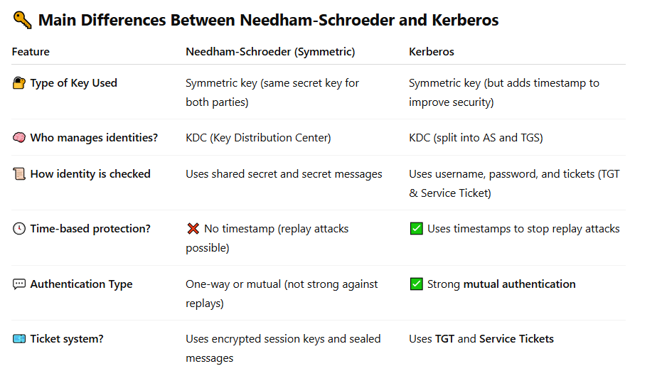
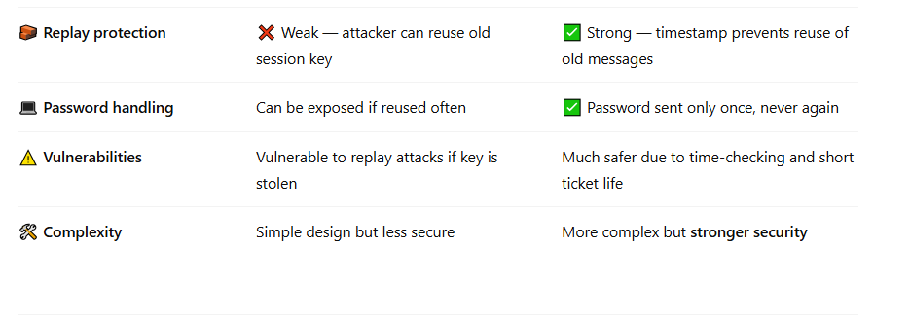

Lecture 18
Discrete Logarithm Problem (DLP) - Simple Explanation
It is an important problem used in cryptography (the science of keeping information secure). Some famous cryptography systems like Diffie-Hellman, ElGamal, and Elliptic Curve Cryptography (ECC) use this problem to make secure keys.
Purpose
DLP saves the secret key (x) from attackers, so that they cannot break encryption, steal private keys, or secretly read or change messages in secure communication systems like Diffie-Hellman or ElGamal.
The problem says:
Find the value of x in this equation:
G ^ x \ mod p = y
Where:
g = Known number (called generator)
p = Known big prime number (modulus)
y = Known result
x = Unknown number (you need to find this)
Why DLP is hard?
- When p is very large (hundreds or thousands of bits), brute force becomes impractical.
- There are no known efficient algorithms to solve DLP for large numbers in a reasonable amount of time — this is what makes it secure for cryptographic use.
Cryptographic Applications
- Diffie-Hellman Key Exchange: Securely share a secret key over an insecure channel
- ElGamal Encryption: Public-key encryption based on DLP
- Elliptic Curve Cryptography (ECC): Variant of DLP over elliptic curves, more efficient with smaller keys
Diffie-Hellman Problem (DHP)
The Diffie-Hellman Problem is the main reason why the Diffie-Hellman key exchange is secure. It helps two people make a shared secret key — even when they talk over an unsafe or public connection.
Why is it important?
It uses one-way functions — which means:
- Easy to do (make the key),
- Very hard to undo (find the key by an attacker).
So, even if an attacker watches the whole process, they cannot find the secret key — unless they can easily solve the DHP (which is very hard).
If DHP becomes easy, the attacker could break the system —
but no easy way is known yet, so it keeps things safe.
Diffie-Hellman Problem (DHP) – Simple Words
Given:
A large prime number (p)
A generator (g)
Two values:
- A = g^a mod p
- B = g^b mod p
But the secret numbers a and b are not known.
Problem:
Find the shared secret key K = g^(ab) mod p — without knowing a or b.
Why is this hard?
Because to find K, the attacker must first figure out either a from A = g^a mod p or b from B = g^b mod p —
but this is the Discrete Logarithm Problem (DLP), which is very hard when p is large.
Do they share A and B on an unreliable (unsafe) channel?
Yes!
The values A = g^a mod p and B = g^b mod p are shared over an unreliable or insecure channel (like the internet or public network) —
It’s okay if attackers see A and B, because they cannot use these to find the secret values a or b or the secret key K, because of the hard Discrete Logarithm Problem (DLP).
Diffie-Hellman Key Exchange
In Diffie-Hellman Key Exchange:
- Alice picks a secret number ‘a’,
and sends A = g^a mod p to Bob.
- Bob picks a secret number ‘b’,
and sends B = g^b mod p to Alice.
Then they both make the shared secret key:
Alice computes:
K=Bª mod p = g^{ba}
Bob computes:
K=A^{b} mod p = g^{ab}
Both get the same shared secret key K.
What does an attacker see?
- The attacker sees only A, B, g, p on the network.
- But they cannot find K = g^(ab) mod p — unless they can solve the hard Diffie-Hellman Problem (DHP), which is very difficult when numbers are large.
Why Is DHP Hard?
- The Diffie-Hellman Problem (DHP) is hard because the Discrete Logarithm Problem (DLP) is hard.
- In most cases, if someone can solve the DHP, they could also solve the DLP — so these two problems are almost equally difficult.
- But in some special or carefully made mathematical groups,
the DHP might be slightly easier than DLP — but this is rare and usually avoided in secure systems.
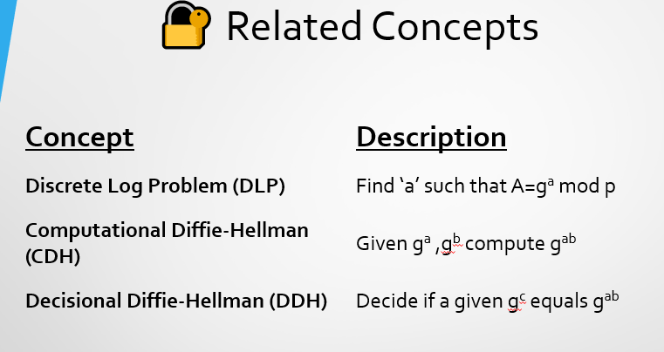
Security Implication
- Most cryptographic protocols rely on CDH or DDH being hard.
- Elliptic Curve Diffie-Hellman (ECDH) uses the same principle with elliptic curves, offering similar security with smaller keys.

